
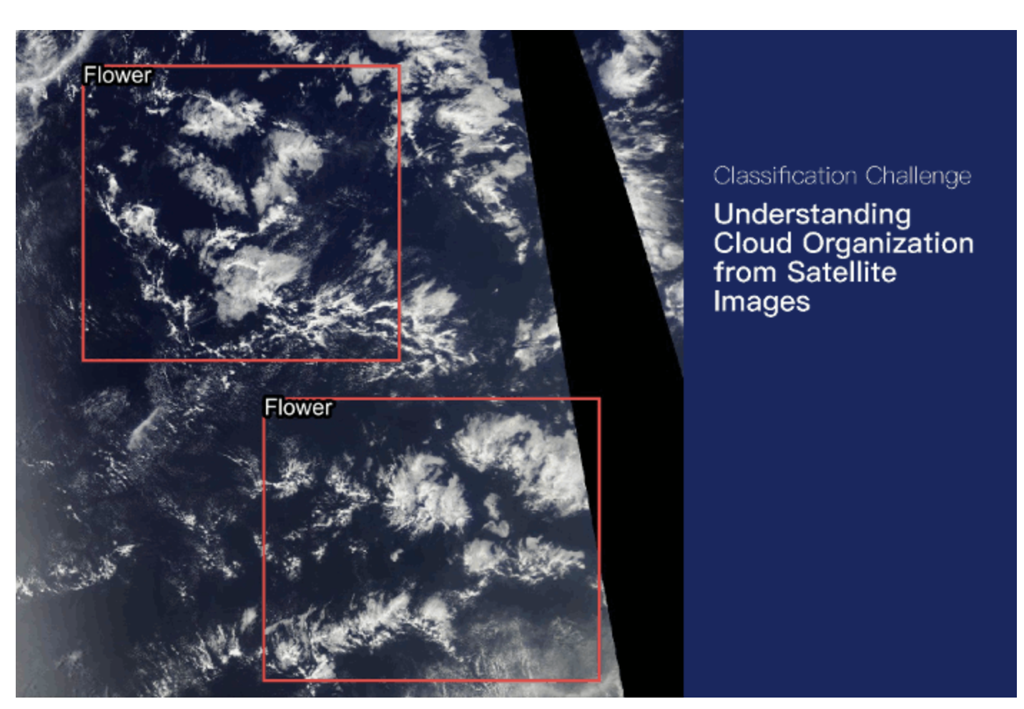

Project: Segmentation of Cloud Images
Authors: Fatemeh Tayebi Naeempour, Mahsa Nakhostinrouhi,
Uwe Rosner and Christian J. Schäfer
Promotion: Bootcamp June 2026
Supervision: Yohan Cohen (Liora)
Project Presentation: 22 September 2026

Table of Content

1. Introduction 5
1.1. Problem and Objective 5
1.2. Course of Analysis 5
2. Exploratory Data Analysis and Data Preparation 6
2.1. Exploratory Data Analysis 6
2.1.1. Data Set Overview 6
2.1.2. Dataset Structure 7
2.1.3. Class Distribution 8
2.1.4. Mask Availability and Cloud Categories per Image 9
2.1.5. Sensor Gap Analysis 10
2.2. Data Preparation 11
2.2.1. RLE Decoding 11
2.2.2. Multi-channel Mask Creation 11
2.2.3. Image and Ground Truth Mask Visualization 11
2.2.4. Image Resizing 12
2.2.5. Normalization 13
2.2.6. Data Augmentation 13
2.3. Data Preparation Results 16
2.3.1. Augmented Images 16
2.3.2. Train/Validation Split 17
2.3.3. Data Loaders 17
2.3.4. Batch Size 17
2.3.5. Data Format 17
3. Cloud Segmentation Models 1: Cloud Segmentation Using U-Net 18
3.1. Executive Summary 18
3.2. Theoretical Background of the U-Net Model 18
3.2.1. Description of U-Net Method 18
3.2.2. Common Applications of U-Net 19
3.2.3. Rationale for using the U-Net for this Cloud Project 20
3.3. Application of the U-Net Model 20
3.3.1. Application of U-Net in this Project 20
3.3.2. Results and Interpretation 21
3.3.3. Final validation metrics 22
3.3.4. Predictions on unseen test images 23
3.4. Conclusion 24
3.4.1. Results Still Needed for a Complete Final Model Assessment 24
3.4.2. Recommended Next Improvements 25
4. Cloud Segmentation Models 2: Cloud Segmentation Using U-Net with ResNet50 26
4.1. Executive Summary 26
4.2. Application of this U-Net model 26
4.2.1. Loss Function 28
4.2.2. Optimizer and Learning Rate 28
4.2.3. Training Configuration 28
4.2.4. Training Results 29
4.3. Conclusion 29
4.3.1. Model Evaluation 29
4.3.2. Prediction Visualization 31
4.3.3. Test Set Prediction 32
5. Cloud Segmentation Models 3: Cloud Segmentation Using PSPNet 34
5.1. Executive Summary 34
5.2. Theoretical Background of the PSPNet Method 34
5.3. Application of the PSPNet 35
5.3.1. Application of PSPNet in this Project 35
5.3.2. Results and Interpretations 37
5.3.3. Final validation metrics 38
5.3.4. Predictions on unseen test images 39
5.4. Conclusion 40
6. Cloud Segmentation Models Comparison 41
6.1. Comparison with the PSP Model with the two U-Net Models 41
6.2. Comparison of Model Predictions 42
6.3. Final Model Comparison 42
6.4. Recommended Model Selection 43
7. Summary and Conclusion 43
References 44

Table of Figures
Figure 1: Initial dataframe of the training dataset 8
Figure 2: Dataset structure after separating image identifiers and cloud categories 8
Figure 1: Distribution of available segmentation masks by cloud type 9
Figure 2: Number of Cloud Types per Image 10
Figure 3: Example of sensor gap detection 11
Figure 4: Satellite image 002be4f.jpg with ground truth segmentation masks 13
Figure 7: Python code to import the albumentations library as A 16
Figure 8: Python code used to train the dataset using CloudSegmentationDataset 17
Figure 5: Original image with masks compared to an augmented version 17
Figure 6: Core U-Net components and their role in the cloud project comparison 20
Figure 7: Project requirements and reasons for using U-Net 21
Figure 8: U-Net architecture used in the four-class cloud-segmentation model 21
Figure 9: Training and validation loss and Dice coefficient across 15 displayed epochs. 23
Figure 10: Model 1 Final validation metrics. 23
Figure 11: Model 1 Interpretation of training and validation behavior. 24
Figure 12: Model 1 predicted cloud pattern masks for randomly selected test images 25
Figure 13: Model 1 Recommended next improvements. 26
Figure 14: Model 2 Detailed architecture of the U-Net with ResNet50 28
Figure 15: Model 2 Training and Validation Loss across 25 Epochs 30
Figure 16: Model 2 Cloud Class, Dice Score and IoU comparison 31
Figure 17: Model 2 Validation Performance of the U-Net with ResNet50 31
Figure 18: Model 2 comparison of Satellite Images, Ground Truth Masks, and Predictions 32
Figure 19: Model 2 Example Test Set Predictions 34
Figure 20: Model 3 Project overview. 35
Figure 21: Model 3 Core PSPNet components and their role in this project. 36
Figure 22: Model 3 instantiated ResNet-34 encoder PSPNet architecture 37
Figure 23: Model 3 training configuration 37
Figure 24: Model 3 training and validation loss (BCE + Dice) over 25 epochs 38
Figure 25: Model 3 training and validation Dice score over 25 epochs 38
Figure 26: Model 3 final validation metrics of the saved model 39
Figure 27: Model 3 Per-class validation scores 39
Figure 28: Model 3 segmentation map for test image 0035ae9.jpg 40
Figure 29: Model 3 segmentation map for test image 004f759.jpg 40
Figure 30: Macro Dice per cloud type, PSPNet vs. U-Net (ResNet-50) comparison 42
Figure 31: Illustrative comparison of model prediction results 43
Figure 32: Final comparison of best validation dice results 43

- Introduction
  - Problem and Objective
Clouds play a crucial role in the Earth’s climate system by influencing energy balance and weather patterns. However, their complex structures and organization make them difficult to represent accurately in climate models. Understanding different cloud patterns can help scientists improve climate predictions and reduce uncertainties in future climate projections.

In this project, we aimed to use satellite images and machine learning techniques to segment and identify different cloud organization patterns. By accurately detecting cloud types and their spatial distribution, this work can contribute to a better understanding of cloud organization and atmospheric processes.

  - Course of Analysis
We used existing data of labelled satellite images to train an algorithm that classifies cloud patterns correctly. Chapter 2 introduces the data set, findings from an exploratory data analysis and how we prepared the dataset.

We developed three different models to identify and classify the prevalent cloud patterns on the satellite image. Chapter 3 to 5 introduce to two U-Net and one PSPnet-based models. Chatper 6 compares the performance of the three models.

The final chapter 7 presents our conclusion.

- Exploratory Data Analysis and Data Preparation
  - Exploratory Data Analysis

Data Set Overview
The dataset used in this project is the Kaggle Understanding Clouds from Satellite Images dataset. It consists of satellite images and corresponding cloud segmentation annotations for four cloud categories: Fish, Flower, Gravel, and Sugar.
The dataset contains 5,546 unique satellite images and 22,184 annotation records, with 5,546 records for each cloud category. The segmentation annotations are provided in Run-Length Encoding (RLE) format through the EncodedPixels column of the training CSV file.
The original dataset images have a resolution of 1400 × 2100 pixels. For this project, the images were processed and resized to 576 × 384 pixels, corresponding to a NumPy shape of 384 × 576 × 3.
The dataset is provided through several files:
- train.csv: contains the RLE-encoded segmentation masks for each image and cloud-label pair in the training set.
- train_images.zip: contains the training satellite images used for model development.
- test_images.zip: contains the test satellite images.
- sample_submission.csv: provides an example of the required output format for segmentation predictions. This file was not used in the current project.
Not all annotation records contain a segmentation mask. Approximately 53.35% of the annotation records contain valid RLE masks, while the remaining records have missing EncodedPixels values. These missing values indicate that no segmentation mask is provided for that particular cloud category in the corresponding image.
The satellite images were obtained from NASA Worldview and were captured by the TERRA and AQUA polar-orbiting satellites using the MODIS instrument. Because an image may be constructed from two satellite orbits, an uncovered area between successive orbits can appear as a black band. This area is not part of the valid image region and must not be considered as a cloud prediction area.
The ground-truth annotations were created through a crowdsourcing process involving 68 scientists. Each image was labeled by approximately three scientists, and the final ground truth was obtained from the union of their annotations after removing the black band areas.
The dataset therefore provides satellite imagery and pixel-level cloud annotations that can be used to formulate the project as a multi-label image segmentation task.

Dataset Structure
The training annotations are stored in a CSV file containing two main columns: Image_Label and EncodedPixels.
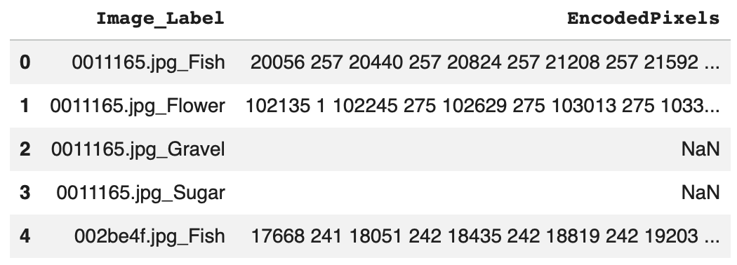
Figure 1: Initial dataframe of the training dataset

The Image_Label column contains both the image identifier and the corresponding cloud category. To make the data easier to process, this column was split into two separate columns: Image_id and Cloud_Type.

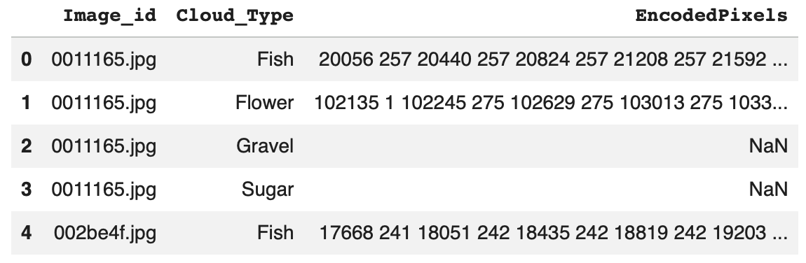
Figure 2: Dataset structure after separating image identifiers and cloud categories

For example, an entry such as 0011165.jpg_Fish is separated into the image identifier 0011165.jpg and the cloud category Fish.
Each image can appear up to four times in the annotation file, once for each cloud category: Fish, Flower, Gravel, and Sugar.
The EncodedPixels column contains the segmentation mask information using Run-Length Encoding (RLE). When a cloud of a given category is present and annotated, its pixel locations are stored as an RLE sequence. Missing values in this column indicate that no mask is available for that particular image-category pair.
The RLE-encoded annotations were later decoded and converted into multi-channel segmentation masks for model training. The detailed preprocessing steps are described in Chapter 2.
This structure allows each satellite image to be associated with a corresponding pixel-level target containing the segmentation information for all four cloud categories.

Class Distribution
The distribution of available segmentation masks was analyzed for the four cloud categories: Fish, Flower, Gravel, and Sugar. The analysis shows that the number of annotated masks is not exactly equal across the four classes.
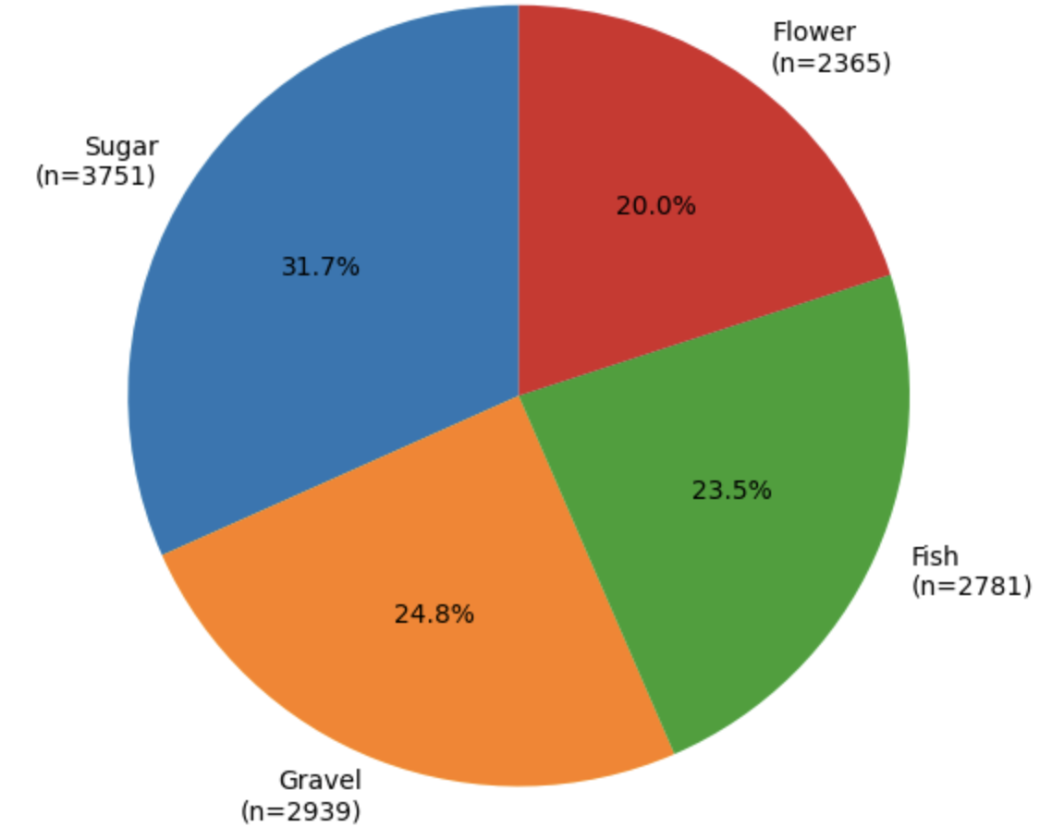
Figure 1: Distribution of available segmentation masks by cloud type
The pie chart shows the proportion of available masks belonging to each cloud category. Sugar represents the largest proportion, while Flower has the smallest proportion.
Overall, the dataset shows a moderate class imbalance, with Sugar having the highest number of available masks and Flower the lowest. Because the imbalance is not severe, no additional class-balancing technique was applied during preprocessing or model training. In cases of stronger class imbalance, techniques such as class-weighted loss could be used to give greater importance to underrepresented classes. However, for this dataset, the observed imbalance was considered moderate enough to allow the model to learn from the original class distribution without introducing additional weighting.

Mask Availability and Cloud Categories per Image
The training dataset contains 22,184 image-category annotation records. Among these records, 11,836 contain segmentation masks, while 10,348 have missing EncodedPixels values. Therefore, 53.35% of the annotation records contain an available segmentation mask, while 46.65% do not. A missing value indicates that no annotated segmentation mask is available for that particular cloud category in the corresponding image. However, this does not mean that the image contains no clouds, since each image can contain one or more of the four cloud categories. The number of cloud categories represented by available annotations was also analyzed for each image.
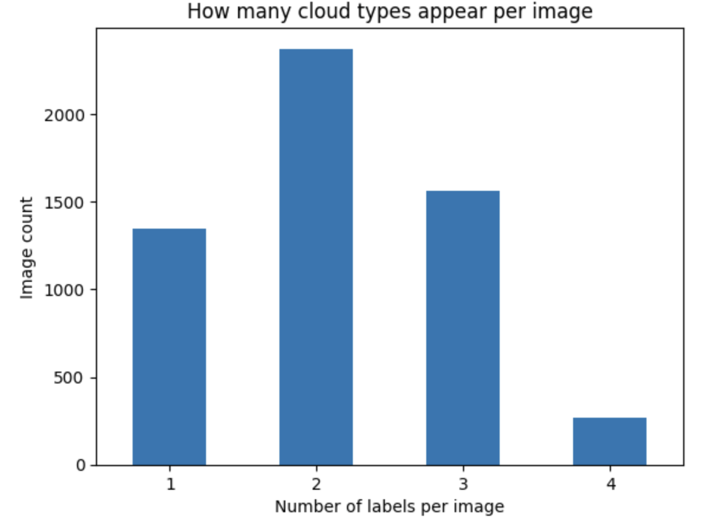
Figure 2: Number of Cloud Types per Image

The count plot shows the number of cloud types represented by available annotations in each image. The results show that images contain between one and four cloud types. Most images contain two cloud types, followed by three and one cloud type, while only a small number of images contain all four cloud types.
This distribution shows that most satellite images contain multiple cloud types, highlighting the complexity of the segmentation task. The model therefore needs to identify and distinguish several cloud categories within the same image.

Sensor Gap Analysis
During the exploration of the satellite images, a black band was observed in some images. This band is caused by an uncovered area between successive satellite orbits and represents a sensor gap rather than a valid image region.
The sensor gap was analyzed to understand the structure of the satellite images and to distinguish the black band from actual cloud regions.
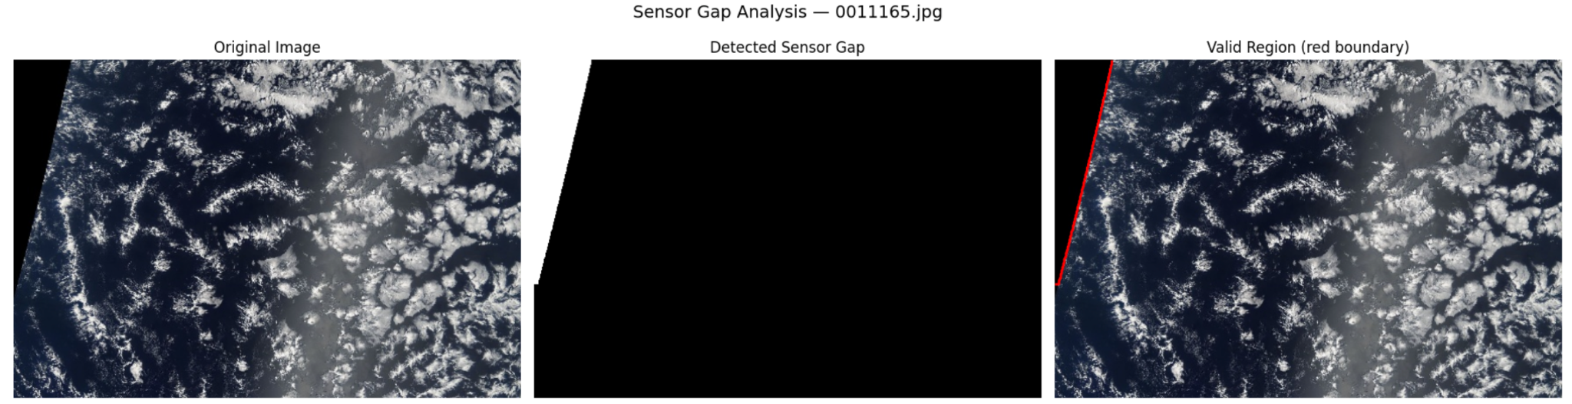
Figure 3: Example of sensor gap detection
What the figure shows:
- Left: Original satellite image.
- Middle: Detected sensor gap (white = gap).
- Right: Valid image region with its boundary.

The visualization shows that the black band does not contain valid satellite information and should not be interpreted as a cloud region. The ground truth annotations already exclude these areas.
In the modeling stage, no additional sensor-gap mask was applied during training or prediction. This approach avoids introducing errors from heuristic pixel-based gap detection and keeps the modeling process focused on the provided ground truth annotations.

  - Data Preparation

RLE Decoding
The segmentation masks in the training dataset are provided in Run-Length Encoding (RLE) format through the EncodedPixels column. RLE represents the locations of segmented pixels using pairs of start positions and run lengths.
To use these annotations for image segmentation, the RLE-encoded values were decoded into binary masks. Each decoded mask has the same spatial dimensions as the processed images, 384 × 576 pixels. Pixels belonging to the corresponding cloud category are assigned a value of 1, while the remaining pixels are assigned a value of 0.
Missing EncodedPixels values were treated as empty masks, since they indicate that no segmentation mask is available for that image-category pair.
The decoded binary masks were then used as the basis for creating the multi-channel ground truth masks described in the next section.

Multi-channel Mask Creation
After decoding the RLE annotations, the binary masks were combined into a single multi-channel mask for each satellite image. Four channels were created, one for each cloud category: Fish, Flower, Gravel, and Sugar.
Each channel represents the segmentation mask of one cloud category, with 1 indicating the presence of the corresponding cloud type and 0 indicating background pixels. Therefore, each processed image is associated with a four-channel ground truth mask with a shape of 384 × 576 × 4.
This representation allows the model to predict the four cloud categories independently for each pixel and provides the ground truth required for multi-label cloud segmentation.

Image and Ground Truth Mask Visualization
To verify the segmentation annotations, a selected satellite image was visualized together with its corresponding ground truth masks. The masks were displayed separately for each cloud category to examine their spatial alignment with the original image.
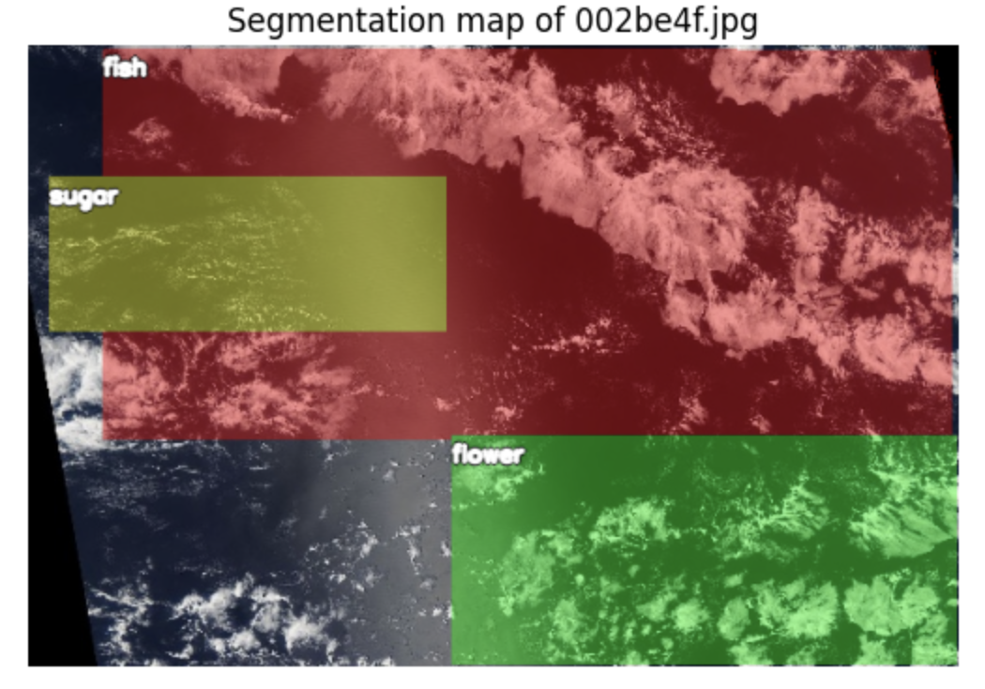
Figure 4: Satellite image 002be4f.jpg with ground truth segmentation masks

The visualization shows the satellite image 002be4f.jpg together with its available ground truth segmentation masks. The masks illustrate the spatial distribution of the annotated cloud regions and their alignment with the original image.
The black band visible in the lower-left corner represents the sensor gap. It is not part of the valid image region, and the ground truth annotations already exclude this area.
This visualization provides a visual check of the segmentation annotations and confirms their alignment with the satellite image before model training.

Image Resizing
The original satellite images have a resolution of 1400 × 2100 pixels. To reduce the computational cost and make the images suitable for model training, the images were resized to 576 × 384 pixels.
The same spatial dimensions were used for the corresponding ground truth masks to ensure that the images and masks remained correctly aligned. After resizing, each image had a shape of 384 × 576 × 3, while each ground truth mask had a shape of 384 × 576 × 4.
This resizing step reduced the input size while preserving the spatial information required for cloud segmentation and made the dataset more suitable for efficient model training.

Normalization
After resizing, the satellite images were normalized before being used as input to the neural networks. ImageNet normalization was applied using the mean values (0.485, 0.456, 0.406) and standard deviations (0.229, 0.224, 0.225) for the RGB channels.
This normalization was used because the models use ImageNet-pretrained encoders. It provides input values with a distribution compatible with the pretrained weights and supports more stable model training.
The ground truth masks were not normalized. They were kept as binary values, where 1 represents the presence of a cloud category and 0 represents its absence.

Data Augmentation
Data augmentation was applied only to the training data to increase the diversity of the satellite images and improve the model’s ability to generalize to unseen images. The validation data was not augmented and was only resized and normalized.
The training augmentation included horizontal and vertical flipping, shifting, scaling, and rotation. Additional transformations included changes in brightness and contrast, gamma adjustment, CLAHE, Gaussian noise, Gaussian blur, and motion blur.
The same spatial transformations were applied to both the images and their corresponding masks to preserve their alignment. Data augmentation was used only during training and was not applied to validation or test images.
For the need of data augmentation let me just quote Aurélien Géron from the 2025 release of his book Hands-On Machine Learning with Scikit-Learn and PyTorch, page 438: “Data augmentation artificially increases the size of the training set by generating many realistic variants of each training instance. This reduces overfitting, making this a regularization technique. The generated instances should be as realistic as possible: ideally, given an image from the augmented training set, a human should not be able to tell whether it was augmented or not. Simply adding white noise will not help; the modifications should be learnable (white noise is not). For example, you can slightly shift, rotate, and resize every picture in the training set by various amounts and add the resulting pictures to the training set (…). To do this, you can use tools available in torchvision.transforms.v2 (e.g., RandomCrop, RandomRotation, etc.). This forces the model to be more tolerant to variations in the position, orientation, and size of the objects in the pictures. You can similarly use transforms to tweak the colors, and contrasts to simulate many different lighting conditions. In general, you can also flip the pictures horizontally (except for text and other asymmetrical objects). By combining these transformations (using Compose), you can greatly increase your training set size.”

So, basically we use it to (1) get the model to be more tolerant to variations in the data and (2) show the model a different variant of each image in every epoch

The second point deserves a remark, because here we deviate slightly from the way Géron describes it above. He adds the generated variants to the training set, which makes that set physically larger. We instead augment on the fly: the transformations are applied inside our Dataset every time an image is requested (see Where the pipeline is applied below). So the number of images per epoch stays exactly the same, but the model practically never sees the very same picture twice. The regularizing effect Géron describes is the same, only the training set size on disk is not affected.

Albumentation library: We chose the albumentations package useful and ready for the task. It is well prepared for image augmentation and also augments the masks, which in our case are the labels. More precisely, and that is what matters for a segmentation task: geometric transformations (flips, rotation) are applied identically to the image and to all of its masks, while photometric ones (brightness, contrast) are applied to the image only. Doing this by hand would be tedious and error-prone.
In opposite to the imgaug package, which we had examined at the beginning of the project, this one is actively maintained and runs with current Python versions.
One note on reproducibility: the package we actually install is albumentationsx (see requirements.txt), the actively maintained successor of albumentations. It is a drop-in replacement and is still imported as albumentations, which is why all code below reads import albumentations as A.

Every transformation has its own probability p, so each call produces a different combination. This is why we picked these four:
- HorizontalFlip and VerticalFlip: our images are satellite images and therefore have no canonical “up”. A flipped satellite image is still a perfectly plausible satellite image, which is exactly the kind of realism Géron asks for. For everyday photos the vertical flip would be a bad idea, an upside-down car is not a realistic training instance.
- Rotate: same argument, and it additionally makes the model less dependent on the orientation of the cloud formations.
- RandomBrightnessContrast: simulates different lighting conditions, i.e. different sun angles and times of the day. We gave it the highest probability, but deliberately kept the default (moderate) limits: brightness and texture are part of what distinguishes the cloud types here, so a too aggressive color transformation would damage the very signal we want to learn.

Two details that matter for the masks:
- Rotate has to fill the corners that become empty after the rotation. With the default settings this is a constant fill with 0, both for the image (black corners) and for the masks (background), so no cloud region is invented in those areas.
- The masks are resampled with nearest-neighbour interpolation (the default mask_interpolation), so they stay strictly binary and no intermediate values sneak into the labels.
The concrete p values were chosen heuristically as a reasonable starting point. We did not tune them, so they remain a candidate for a later optimization.

Library Setup:
import albumentations as A
pipeline = A.Compose([
A.HorizontalFlip(p=0.3),
A.VerticalFlip(p=0.3),
A.RandomBrightnessContrast(p=0.8),
A.Rotate(p=0.6)
])
# Call the pipeline giving it an image and the stack of its masks
# NOTE: `csi` is an instance of our custom class `CloudSegmentationImage` which
# gathers the image together with the labels (the masks)
transformed_data = pipeline(
image=csi.get_image_rgb(),
masks=csi.get_mask_stack()
)
Figure 7: Python code to import the albumentations library as A

Augmenting the training set only is essential here: the validation set has to stay untouched, otherwise its score would no longer describe the performance on real, unmodified data. On top of that it would change from epoch to epoch for reasons that have nothing to do with the model.

The pipeline is handed over to our CloudSegmentationDataset, which applies it in __getitem__, that is once per image and epoch:

train_dataset = CloudSegmentationDataset(
train_labels_df, TRAIN_PATH, pipeline=pipeline
)
# No augmentation for validation, so it reflects real-world performance
val_dataset = CloudSegmentationDataset(val_labels_df, TRAIN_PATH, pipeline=None)
Figure 8: Python code used to train the dataset using CloudSegmentationDataset

  - Data Preparation Results

Augmented Images
The figure below shows one image with its mask overlay, once in the original and once after passing through the pipeline. Note how the masks follow the geometric transformations of the image:

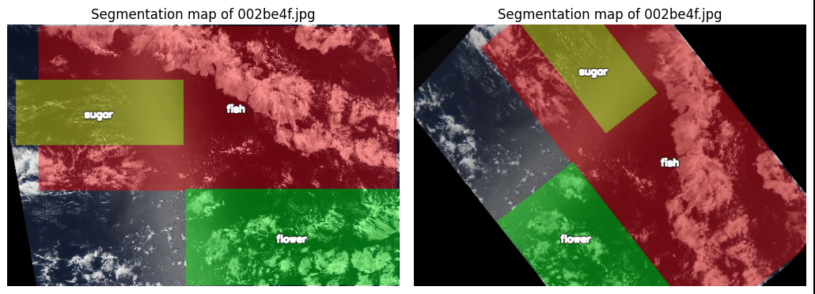
Figure 5: Original image with masks compared to an augmented version

How much the augmentation actually contributes to the model quality is discussed together with the training results in the model chapters.

Train/Validation Split
The dataset was divided into two subsets: 90% for training and 10% for validation. The split was performed at the image level using a fixed random state of 42.
- Training images: 4,991
- Validation images: 555
- Total: 5,546 images
The validation set was used to evaluate the model during training and to monitor its performance on unseen images.

Data Loaders
The training and validation datasets were loaded using PyTorch DataLoader. A batch size of 8 was used for both datasets.
The training DataLoader shuffled the training samples to provide a different order of images during each epoch. The validation DataLoader did not shuffle the data because the order of validation samples does not need to be randomized.
The DataLoaders were configured with num_workers=0 and pin_memory=True to control data loading and support efficient data transfer to the GPU.

Batch Size
A batch size of 8 was used for both the training and validation datasets. This means that the model processes 8 images at a time before updating its weights during training.
Using a batch size of 8 provides a balance between computational efficiency and GPU memory usage.

Data Format
After preprocessing, the images have the shape (3, 384, 576) and the corresponding masks have the shape (4, 384, 576). The images contain three RGB channels, while the masks contain four channels corresponding to Fish, Flower, Gravel, and Sugar.
The data is then loaded by the DataLoader in batches of 8. Therefore, the final input shapes used by the model are:
- Images: [8, 3, 384, 576]
- Masks: [8, 4, 384, 576]
Here, 8 represents the batch size, 3 represents the RGB channels, and 4 represents the four cloud classes.

- Cloud Segmentation Models 1: Cloud Segmentation Using U-Net
  - Executive Summary
This section describes the U-Net method used in the cloud-segmentation project. It explains why it is suitable for the task, documents the network architecture applied in the project, and interprets the available validation results.
The current model performs four-channel segmentation, producing independent Fish, Flower, Gravel, and Sugar masks for each 384 × 576 RGB image.
The learning curves show consistent improvement over 15 epochs. Training and validation losses both decrease and remain close to one another, while Dice scores increase. This indicates that the model is learning and there is no strong sign of overfitting in the displayed run.
However, the final validation Dice coefficient of 0.2462 is still modest, so the current model should be treated as a baseline that requires further improvement before strong segmentation accuracy can be claimed.
The trained model was also applied to four unseen Kaggle test images and produced separate Fish, Flower, Gravel, and Sugar masks; these predictions provide a qualitative demonstration only because ground-truth test masks are not available.
Key validation results:
- Dice = 0.2462
- IoU = 0.3466
- loss = 1.0770
These metrics were computed with different definitions in the project code, so Dice and IoU should not be compared as if they were mathematically paired values

  - Theoretical Background of the U-Net Model

Description of U-Net Method
U-Net is a convolutional neural network architecture designed for image segmentation. Instead of assigning one label to an entire image, it produces a spatial prediction at pixel level. Its characteristic U-shaped structure combines a contracting encoder with an expanding decoder and connects corresponding levels with skip connections.

Component | Role in U-Net | Role in this project
Encoder | Extracts increasingly abstract image features while reducing spatial resolution. | Learns cloud texture, shape, brightness, and larger spatial patterns.
Bottleneck | Represents the most compressed and high-level feature description. | Combines broad contextual information about cloud organization.
Decoder | Upsamples the compressed representation back toward the original image size. | Reconstructs the location and extent of cloud regions.
Skip connections | Pass fine spatial detail directly from encoder layers to matching decoder layers. | Help preserve boundaries and local cloud structure that could be lost during pooling.
Output layer | Produces one or more segmentation maps. | Produces four sigmoid probability maps: Fish, Flower, Gravel, and Sugar.
Figure 6: Core U-Net components and their role in the cloud project comparison

For the current four-mask task, the output is multi-label rather than softmax multiclass segmentation. A pixel can receive independent probabilities for the four cloud masks, so the final layer uses four sigmoid channels. This differs from the earlier binary version of the project, where the four masks were merged into one cloud/non-cloud mask.

Common Applications of U-Net
U-Net was originally introduced for biomedical image segmentation, but its encoder-decoder structure is useful in many domains where object location and shape matter. Typical applications include:
- Medical imaging: segmenting organs, tumors, lesions, and cells.
- Remote sensing and Earth observation: mapping clouds, water, vegetation, land cover, roads, and buildings.
- Agriculture and environmental monitoring: crop boundaries, disease areas, burned regions, and habitat mapping.
- Autonomous and robotic vision: separating roads, vehicles, pedestrians, and other scene components.
- Industrial inspection: locating defects, cracks, or damaged regions in imagery.

Rationale for using the U-Net for this Cloud Project
The project requires spatial masks, not only image-level labels. It must determine where cloud-pattern regions occur in each satellite image. U-Net is therefore appropriate because it returns a prediction for each pixel while preserving spatial structure.

Project requirement | Why U-Net fits
Pixel-level output | U-Net produces full-resolution segmentation maps rather than a single image label.
Irregular cloud regions | Convolutions learn local texture while deeper layers capture larger cloud structures.
Need for spatial detail | Skip connections restore fine information lost during downsampling.
Four cloud masks | The final layer can be changed from 1 output channel to 4 independent channels.
Moderate training-data size | Data augmentation and a compact U-Net can be trained without requiring a very large foundation model.
Figure 7: Project requirements and reasons for using U-Net

  - Application of the U-Net Model

Application of U-Net in this Project
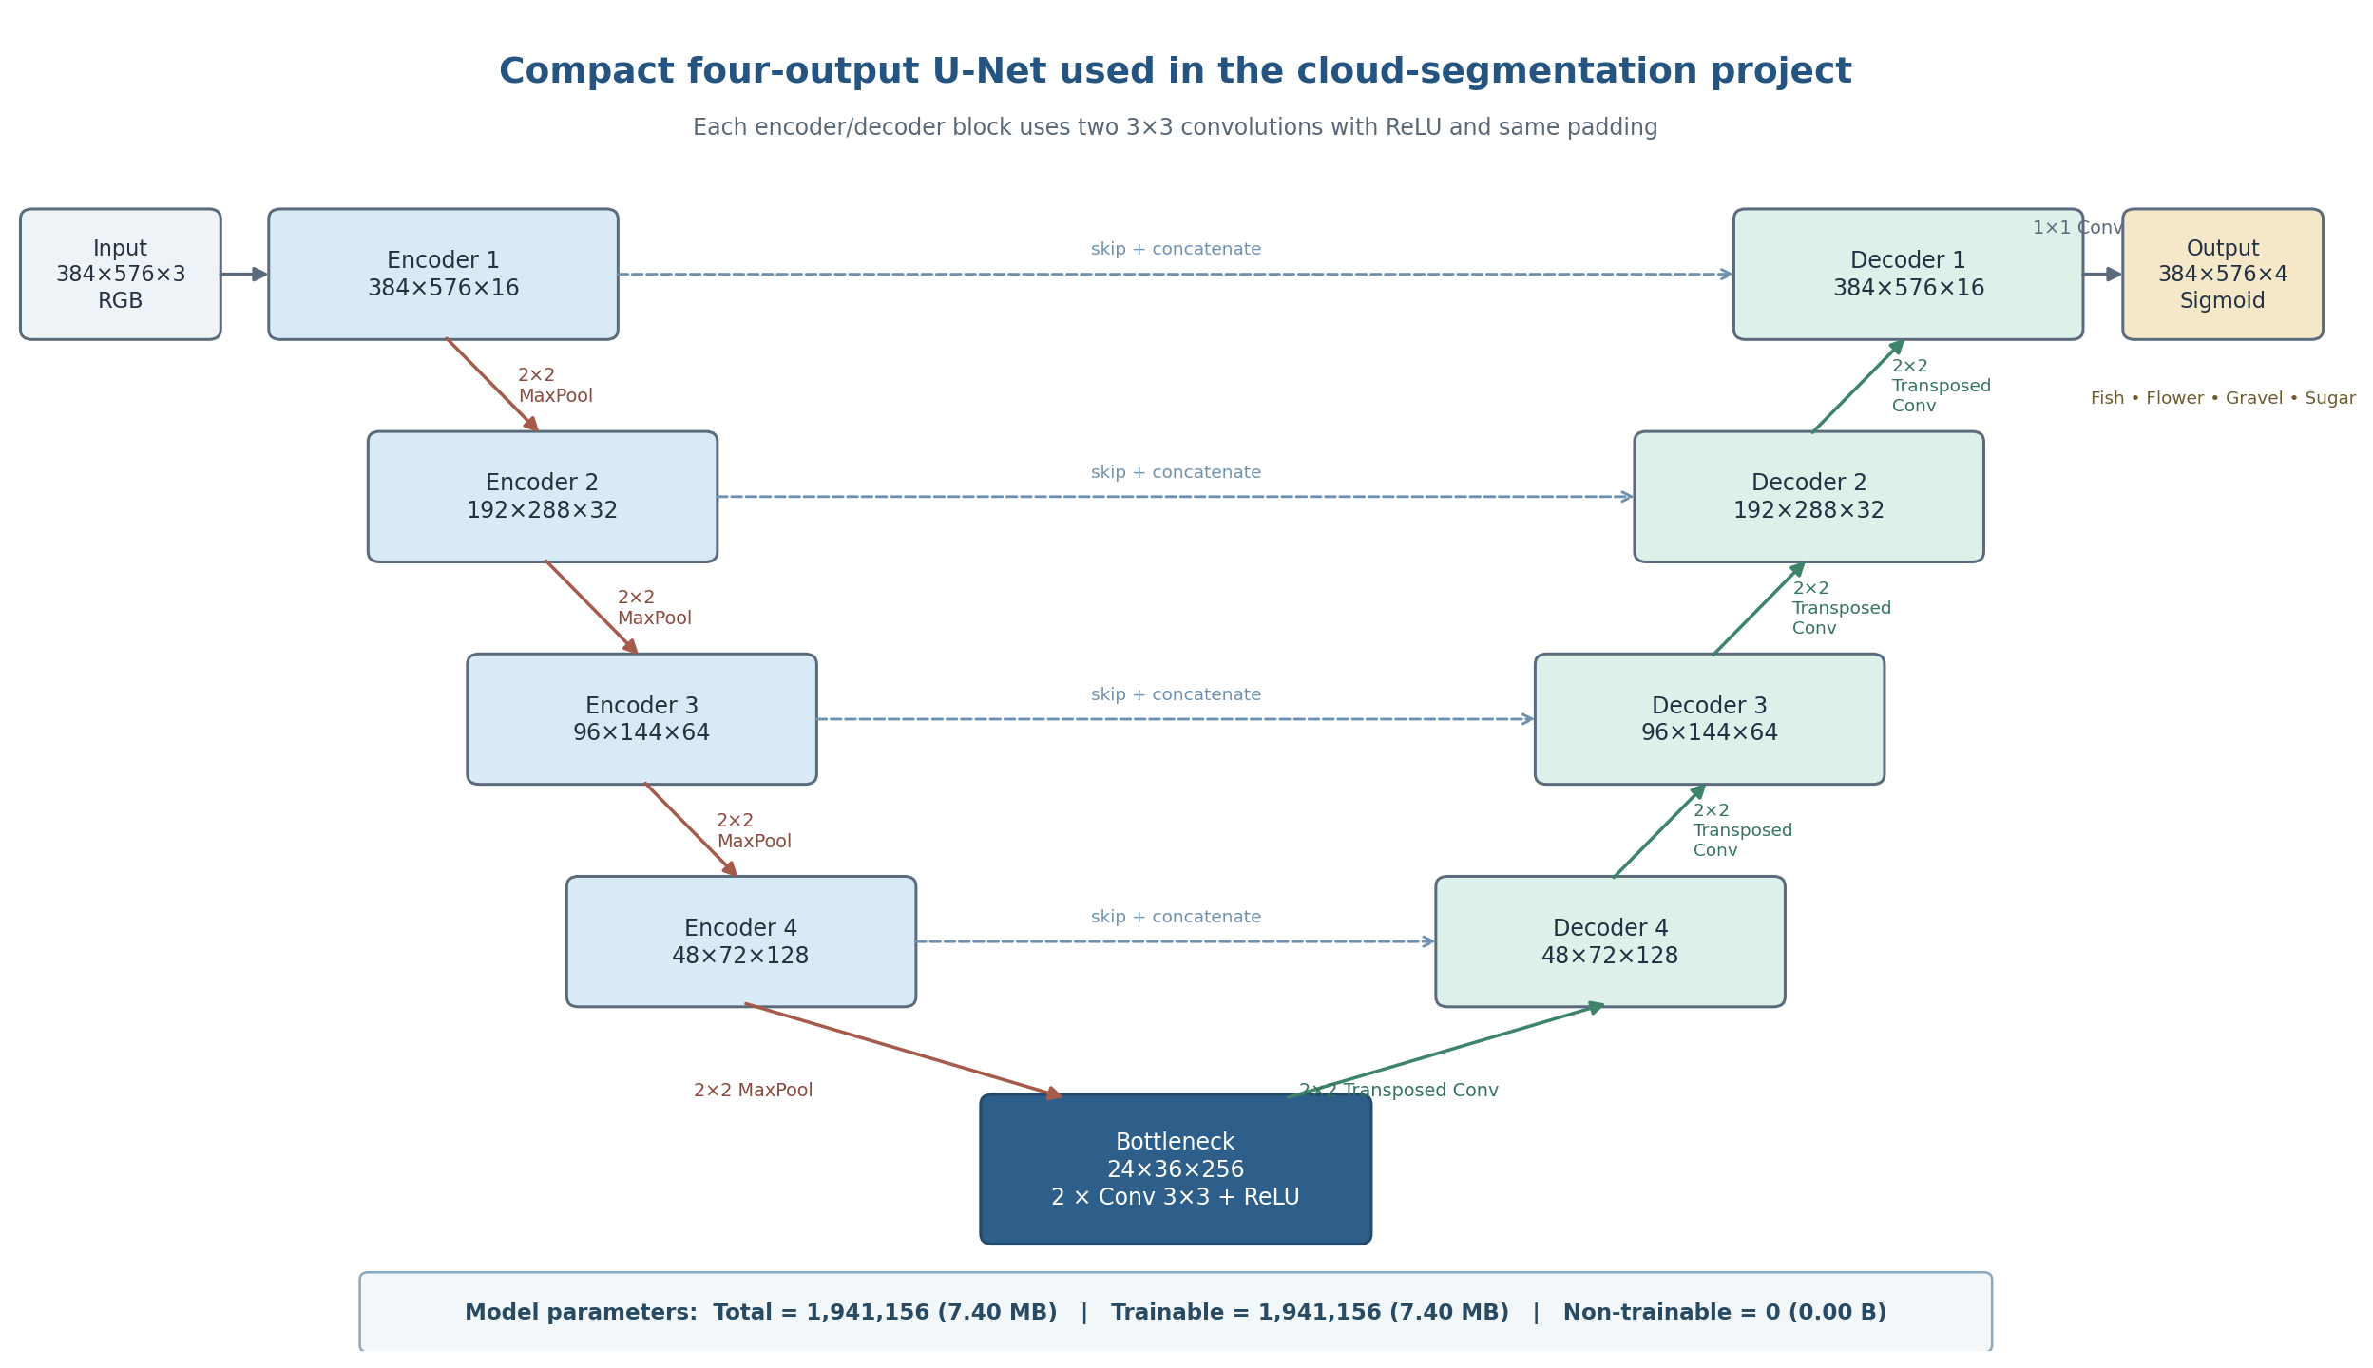
Figure 8: U-Net architecture used in the four-class cloud-segmentation model

U-net Architecture. The project uses a compact U-Net that receives a 384 × 576 RGB satellite image and returns four full-resolution probability masks, one for each cloud class: Fish, Flower, Gravel, and Sugar. The architecture preserves the standard U-Net encoder–bottleneck–decoder structure with skip connections, while using a relatively small number of filters to keep the model computationally manageable.
Input and encoder. The input is a 384 × 576 × 3 RGB image. Four encoder levels progressively learn richer cloud features. Each level applies two 3 × 3 convolutions with ReLU activation and same padding, followed by 2 × 2 max pooling. The number of feature channels increases from 16 to 32, 64, and 128, while the spatial resolution is reduced from 384 × 576 to 48 × 72.
Bottleneck. After the final pooling operation, the bottleneck operates at 24 × 36 pixels with 256 feature channels. It contains two 3 × 3 convolutional layers and captures the most compressed, high-level representation of the cloud patterns.
Decoder and skip connections. The decoder restores spatial resolution using 2 × 2 transposed convolutions. At each level, the upsampled decoder features are concatenated with the corresponding encoder features through a skip connection. These skip connections help recover spatial detail and boundaries that may be weakened during pooling. The decoder channels decrease from 128 to 64, 32, and 16 as the image returns to its original resolution.
Output layer. A final 1 × 1 convolution produces four channels with sigmoid activation. Each channel is an independent probability map for Fish, Flower, Gravel, or Sugar. Sigmoid is appropriate because the cloud masks are treated independently rather than forcing every pixel to belong to exactly one class.
Model size. The network contains 1,941,156 parameters (7.40 MB). All 1,941,156 parameters are trainable, and there are 0 non-trainable parameters. This matches the architecture shown in Scheme 1 and confirms that the model does not include layers with stored non-trainable statistics such as Batch Normalization in this baseline configuration.

Results and Interpretation
The loss curves decrease consistently. Training loss falls from approximately 1.29 at the beginning to about 1.08 by the final displayed epoch, while validation loss falls from approximately 1.26 to 1.077. The two curves remain close throughout training. This is a positive sign because it indicates that the model is improving on both training and unseen validation data, with no clear divergence that would indicate strong overfitting.
The Dice coefficient also improves. Training Dice rises from about 0.14 to roughly 0.24, and validation Dice rises to approximately 0.246. The validation curve fluctuates slightly, which is normal, but the overall trend remains upward. The final validation Dice being slightly above training Dice is not concerning in this setup; training data are augmented on the fly, which can make training batches harder than the unaugmented validation images.
The important limitation is the absolute Dice level. A Dice value around 0.25 indicates that predicted cloud-pattern regions still overlap the ground truth only modestly. Therefore, the learning trend is encouraging, but the segmentation quality is not yet strong.

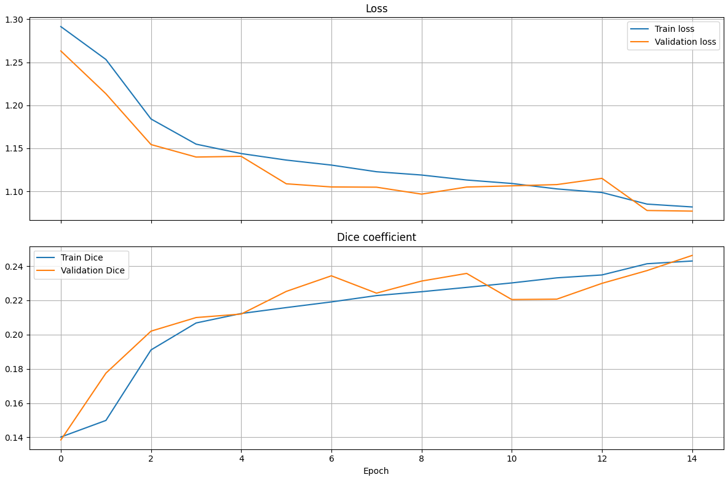
Figure 9: Training and validation loss and Dice coefficient across 15 displayed epochs.

Final validation metrics

Metric | Validation value | Interpretation
Dice coefficient | 0.2462 | Higher is better. The current overlap is modest and indicates room for substantial improvement.
IoU coefficient | 0.3466 | Higher is better. This value is threshold-based in the current implementation and should be interpreted independently of the soft Dice value.
Loss | 1.0770 | Lower is better. The reduced loss relative to early epochs confirms that optimization progressed.
Figure 10: Model 1 Final validation metrics.

Taken together, the results show successful training behavior but limited final segmentation accuracy. The absence of a large train–validation gap suggests that the main issue is not obvious overfitting. Instead, the model may still be underfitting the complexity of the four cloud patterns, may be affected by class imbalance, or may require better thresholding and stronger feature extraction.

Observation | What it means
Loss decreases for train and validation | The optimizer is learning useful parameters and generalization is improving during the displayed epochs.
Train and validation curves remain close | No strong evidence of overfitting is visible in this run.
Dice increases but remains low | The model is learning the task, but predicted masks still have limited overlap with reference masks.
Validation Dice slightly exceeds train Dice | This can occur because training images are augmented while validation images are not.
IoU is numerically above Dice | The project uses different aggregation/threshold rules for the two metrics, so the two values should not be directly compared.
Figure 11: Model 1 Interpretation of training and validation behavior.

Predictions on unseen test images
To examine how the trained four-channel U-Net behaves on data that were not used for training or validation, the model was applied to four randomly selected Kaggle test images. For each image, the model produced four binary segmentation masks, corresponding to Fish, Flower, Gravel, and Sugar. White areas indicate pixels predicted as belonging to the named cloud-pattern class, while black areas indicate pixels not assigned to that class.
The predictions differ substantially among the four images, showing that the model does not return the same class pattern for every scene. In the first image (90897a5.jpg), Fish and Flower are almost absent, while large regions are assigned to Gravel and Sugar. In the second image (d6af239.jpg), the model predicts clear Fish regions and smaller Flower, Gravel, and Sugar regions. The third image (700e9bc.jpg) contains predicted Fish and Flower regions, almost no Gravel, and only limited Sugar. In the fourth image (0078e5a.jpg), Fish is the most prominent predicted class, while Flower is nearly absent and Gravel and Sugar occur only in localized areas.
These examples confirm that the model can generate four independent spatial masks on unseen images and can assign different cloud-pattern combinations to different scenes. The results should not, however, be interpreted as a measurement of test accuracy. The Kaggle test images do not include ground-truth masks, so Dice, IoU, false-positive rates, and false-negative rates cannot be computed for these examples. Quantitative assessment therefore remains based on the labeled validation set, while Figure 2 serves as a qualitative check of the model's behavior on unseen data.

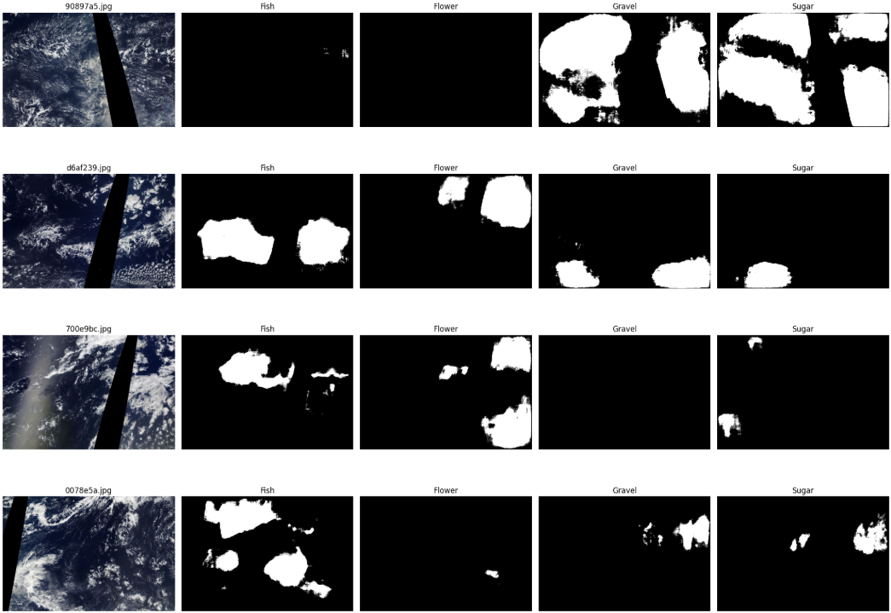
Figure 12: Model 1 predicted cloud pattern masks for randomly selected test images

  - Conclusion
U-Net is well suited to this project because the task requires spatial cloud masks rather than only image-level labels. The encoder-decoder structure and skip connections allow the model to combine broad cloud context with fine spatial detail. The implementation was adapted from binary segmentation to four independent cloud-pattern channels by preserving Fish, Flower, Gravel, and Sugar masks separately and using a four-channel sigmoid output layer.
The current validation run shows stable learning: both losses decrease and Dice improves without a clear sign of overfitting. Nevertheless, the final Dice coefficient of 0.2462 indicates that segmentation overlap remains limited. The current model should therefore be considered a baseline. The qualitative predictions on four unseen test images demonstrate that the model can produce distinct Fish, Flower, Gravel, and Sugar masks for new scenes, but these images cannot provide quantitative test accuracy because their ground-truth masks are unavailable. Per-class evaluation, threshold optimization, qualitative validation-mask inspection, and comparison with stronger U-Net variants remain the most important next steps.

Results Still Needed for a Complete Final Model Assessment
The available results now include the training curves, overall validation metrics, and qualitative predictions on four unseen test images. Several additional quantitative results would still strengthen a final scientific or project report:
- Per-class Dice and IoU for Fish, Flower, Gravel, and Sugar. These results show whether one cloud class is much harder than the others.
- A threshold-selection result on the validation set. A global threshold can be used for simple comparison, followed by per-class threshold optimization for the selected final model.
- Qualitative validation examples showing: original image, true mask, predicted probability, and predicted mask for each class.
- A model-selection table if additional architectures are trained. Use mean validation Dice as the primary selection metric, mean validation IoU as secondary, and validation loss as supporting information.

Recommended Next Improvements

Priority | Action | Reason
1 | Calculate per-class Dice/IoU and inspect class frequencies. | Identifies weak classes and possible imbalance.
2 | Optimize the segmentation threshold on validation data. | The default 0.5 cutoff may not be optimal; class-specific thresholds may improve final masks.
3 | Compare a stronger U-Net variant (e.g., more filters, BatchNorm, or pretrained encoder). | Current Dice suggests the baseline may not capture enough discriminative features.
4 | Review augmentation strength and class balance. | Ensures training data remain realistic and minority cloud classes are represented.
5 | Save model, CSV training history, split lists, thresholds, and configuration. | Makes results reproducible after Colab/kernel restarts.
Figure 13: Model 1 Recommended next improvements.

- Cloud Segmentation Models 2: Cloud Segmentation Using U-Net with ResNet50
  - Executive Summary
The second deep learning model used in this project was a U-Net architecture with a ResNet50 encoder. The model was implemented using the segmentation_models_pytorch library.
The same theory introduced in chapter 3 applies to this application of the U-Net model. To avoid repetition, we will only focus on the distinct application of this U-Net model throughout this chapter.

  - Application of this U-Net model
The ResNet50 encoder was initialized with ImageNet-pretrained weights. It receives RGB satellite images with three input channels and extracts hierarchical features from the images. The U-Net decoder then uses these features to recover the spatial information required for pixel-level segmentation.
The model produces four output channels corresponding to the four cloud categories: Fish, Flower, Gravel, and Sugar. The model uses activation=None, which means that it produces raw logits. The sigmoid function is applied later to convert these outputs into probabilities for loss calculation and prediction.
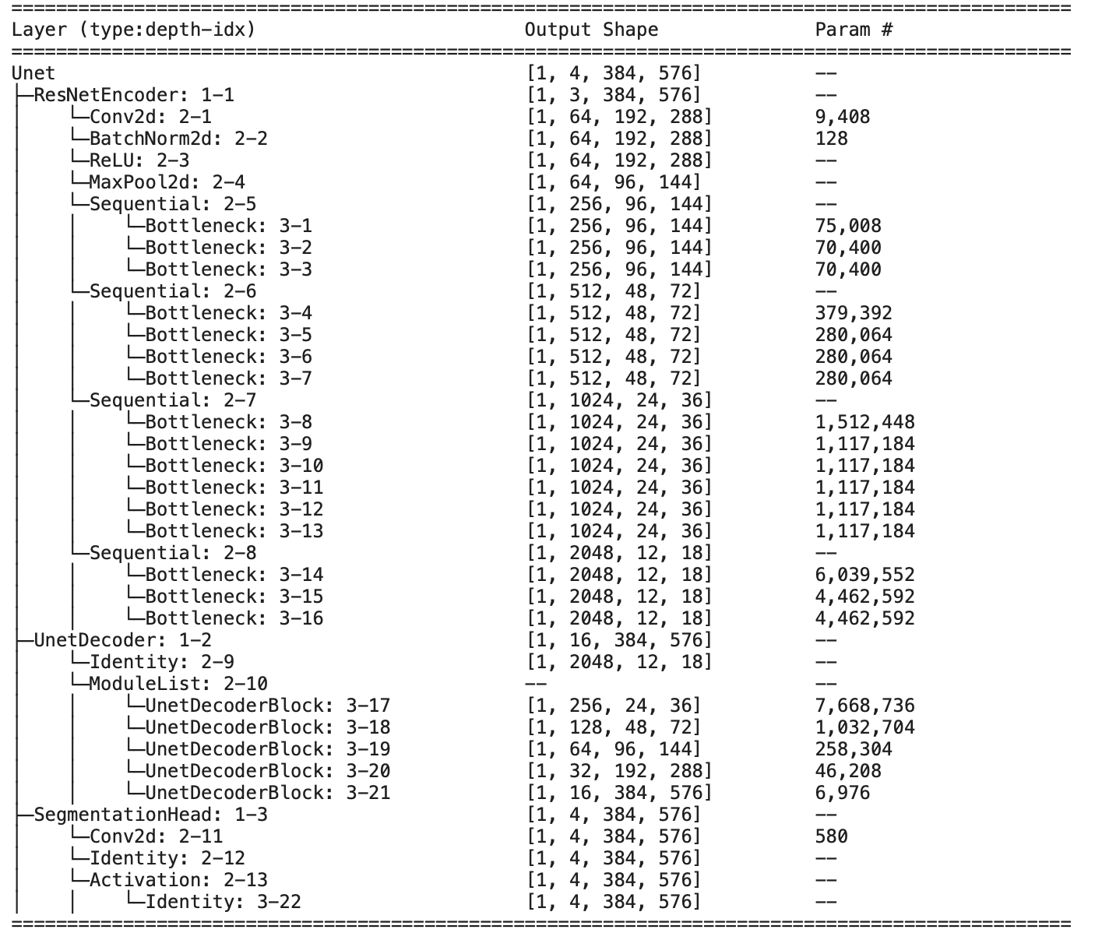
Figure 14: Model 2 Detailed architecture of the U-Net with ResNet50

The architecture contains 32,521,540 trainable parameters. All model parameters are trainable, with 0 non-trainable parameters.
Figure 14 presents the detailed architecture of the U-Net with ResNet50, including the layers, output shapes, and number of parameters at each stage.
The architecture consists of three main parts: the ResNet50 encoder, the U-Net decoder, and the segmentation head.
The ResNet50 encoder progressively reduces the spatial resolution of the input image from 384 × 576 to 12 × 18, while increasing the number of feature channels from 64 to 2048. This allows the model to learn increasingly complex and high-level features from the satellite images.
The U-Net decoder then gradually restores the spatial resolution from 12 × 18 back to 384 × 576. The decoder blocks reduce the number of channels from 256 to 16 while recovering spatial information needed for accurate segmentation.
Finally, the segmentation head uses a convolutional layer to produce 4 output channels, one for each cloud category. Therefore, the final output has the shape [1, 4, 384, 576].

Loss Function
A custom Dice-BCE loss function was used to train the model. It combines Binary Cross-Entropy (BCE) loss and Dice loss.
The total loss was calculated as a weighted combination of the two components, with a higher weight assigned to Dice loss:
- BCE loss weight: 0.3
- Dice loss weight: 0.7
The Dice component helps the model improve the overlap between the predicted cloud regions and the ground-truth masks, while BCE helps classify each pixel correctly.
The final loss was calculated as:
Total Loss = 0.3 × BCE Loss + 0.7 × Dice Loss

Optimizer and Learning Rate
The AdamW optimizer was used to update the model parameters during training. The initial learning rate was set to 8 × 10⁻⁵, and the weight decay was set to 1 × 10⁻⁴.
AdamW was selected to provide stable parameter updates while weight decay helps reduce overfitting and improve generalization.
A ReduceLROnPlateau scheduler was also used. When the validation loss stopped improving, the learning rate was reduced by a factor of 0.5 after 3 consecutive epochs without improvement.

Training Configuration
The model was trained for a maximum of 25 epochs with a batch size of 8. During training, the model was evaluated on the validation set after each epoch.
Early stopping was used with a patience of 5 epochs. If the validation performance did not improve for five consecutive epochs, training was stopped to reduce unnecessary training and help prevent overfitting.
The best-performing model was saved during training based on its validation Dice score. The saved checkpoint was then used for the final validation evaluation and test predictions.

Training Results
The model was trained for 25 epochs. During training, both training loss and validation loss were monitored, together with the validation Dice score.
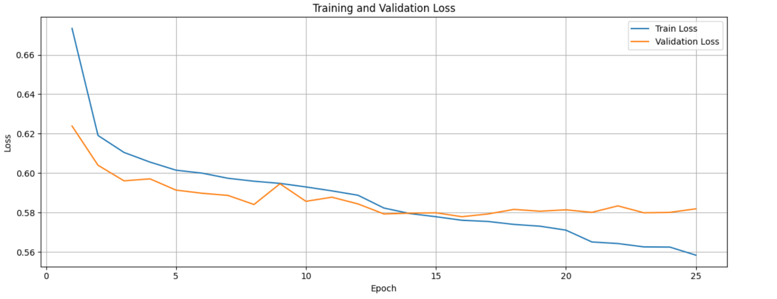
Figure 15: Model 2 Training and Validation Loss across 25 Epochs

The training loss gradually decreased from 0.6734 in the first epoch to 0.5584 in the final epoch. The validation loss also improved during training, reaching its lowest value of approximately 0.5779 at epoch 16, before showing small fluctuations in the later epochs.
The validation Dice score generally improved during training and reached 0.5317 at epoch 25. The training results indicate that the model continued to learn throughout the training process, although the validation performance fluctuated between epochs. Figure 3.1 shows the training and validation loss curves across the 25 epochs.

  - Conclusion

Model Evaluation
After training, the best-performing U-Net with ResNet50 model was evaluated on the validation set. The evaluation was based on the Dice score and Intersection over Union (IoU).
The overall Macro Dice score was 0.6118, while the Mean IoU was 0.4432. These results indicate that the model achieved a moderate level of segmentation performance on the validation images.
The Dice score was also calculated separately for each cloud category. Flower achieved the highest Dice score of 0.6962, while Fish had the lowest score of 0.5478. The results for Gravel and Sugar were 0.5729 and 0.6301, respectively.
Cloud Class | Dice Score | IoU
Fish | 0.5478 | 0.3772
Flower | 0.6962 | 0.5340
Gravel | 0.5729 | 0.4014
Sugar | 0.6301 | 0.4600
Macro / Mean | 0.6118 | 0.4432
Figure 16: Model 2 Cloud Class, Dice Score and IoU comparison

The higher performance for Flower suggests that this class was easier for the model to segment, while Fish was more challenging. Overall, the model was able to detect the four cloud categories, but the segmentation quality varied between classes.
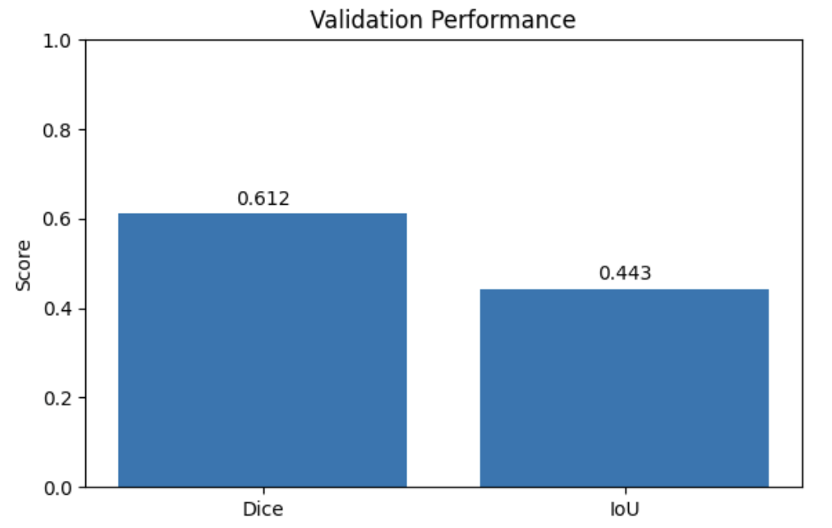
Figure 17: Model 2 Validation Performance of the U-Net with ResNet50

Figure 17 compares the overall Dice score and Mean IoU on the validation set.

Prediction Visualization
To visually evaluate the segmentation results, predictions from the trained model were compared with the original satellite images and the corresponding ground-truth masks.
Four validation images were selected for visualization. For each image, the original satellite image, the ground-truth mask contours, and the predicted mask contours are shown side by side.
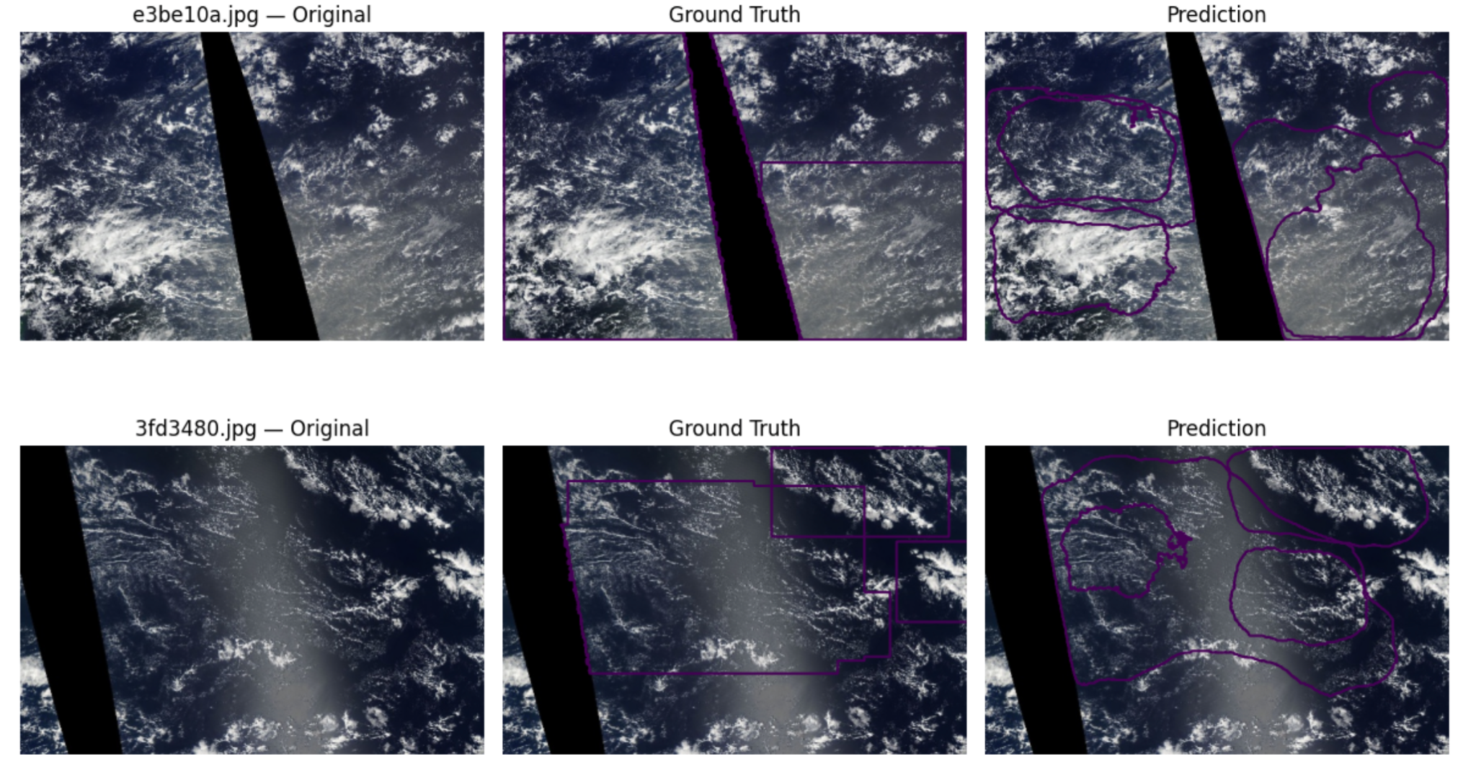
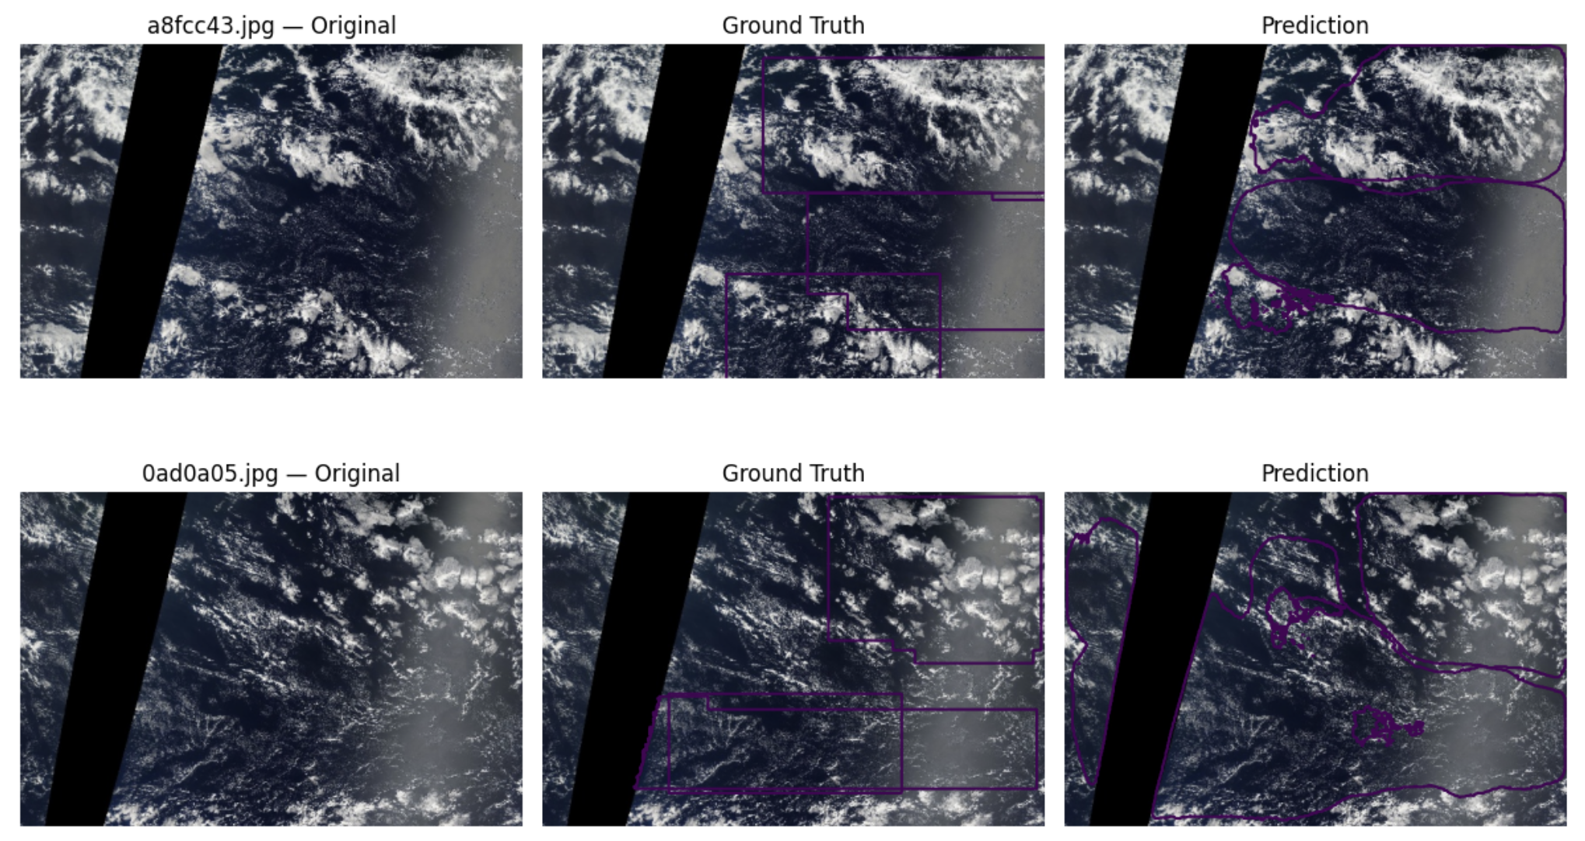
Figure 18: Model 2 comparison of Satellite Images, Ground Truth Masks, and Predictions

The visual comparison shows that the model was able to detect the main cloud regions in the selected validation images. However, some differences can be observed between the predicted contours and the ground-truth contours, particularly in the boundaries and coverage of some cloud regions. Some predicted regions are smaller or do not completely overlap with the corresponding ground-truth regions.

Test Set Prediction
After evaluating the model on the validation set, the selected U-Net with ResNet50 model was used to generate predictions for the test images.
The test set contained 3,698 satellite images. The same preprocessing used for the validation data was applied to the test images, including resizing and ImageNet normalization.
The trained model generated four output channels corresponding to Fish, Flower, Gravel, and Sugar. A sigmoid function was applied to convert the model outputs into probabilities, and a threshold of 0.5 was used to obtain binary segmentation masks.
The predicted masks were then converted back to Run-Length Encoding (RLE) format. A submission file was created containing one prediction for each image and cloud category. The final submission contained 14,792 rows, corresponding to 3,698 test images × 4 cloud categories.
Figure 3.4 shows predictions generated by the selected U-Net with ResNet50 model on seven test images. For each image, the predicted regions of the four cloud categories are displayed on the original satellite image. The different colors represent the four cloud classes: Fish, Flower, Gravel, and Sugar. These examples provide a visual overview of the model’s predictions on previously unseen test images.

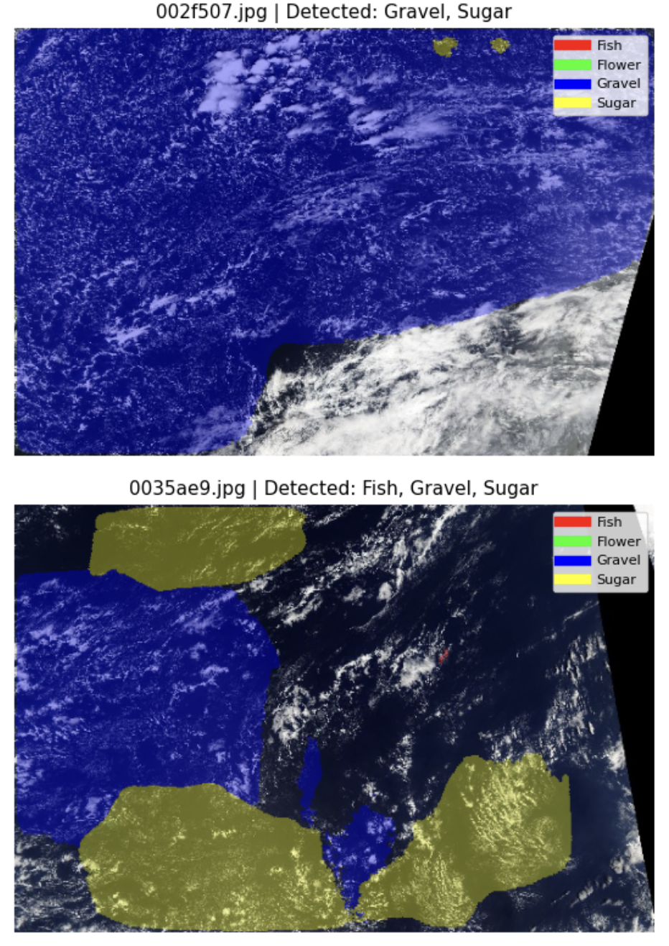 | 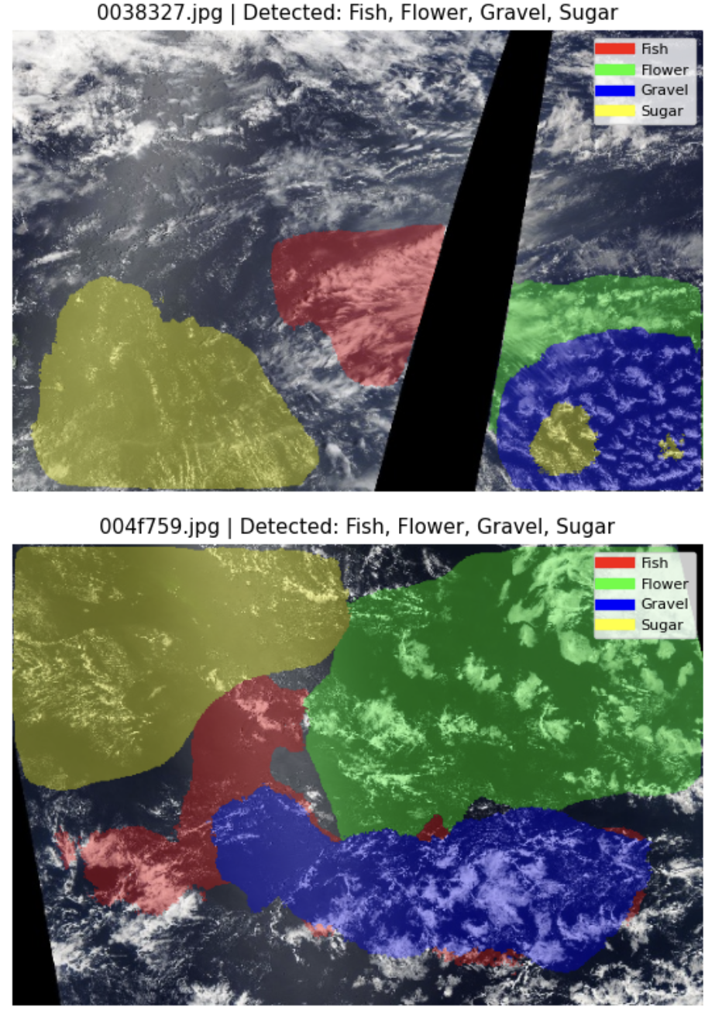
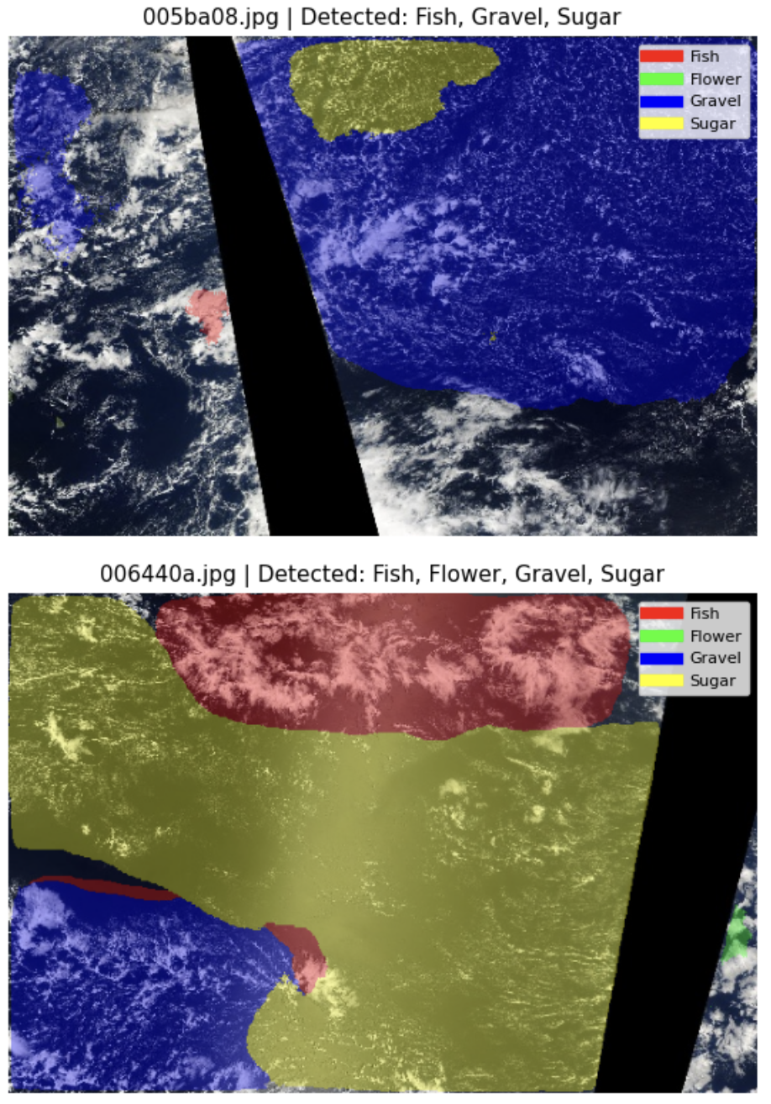 | 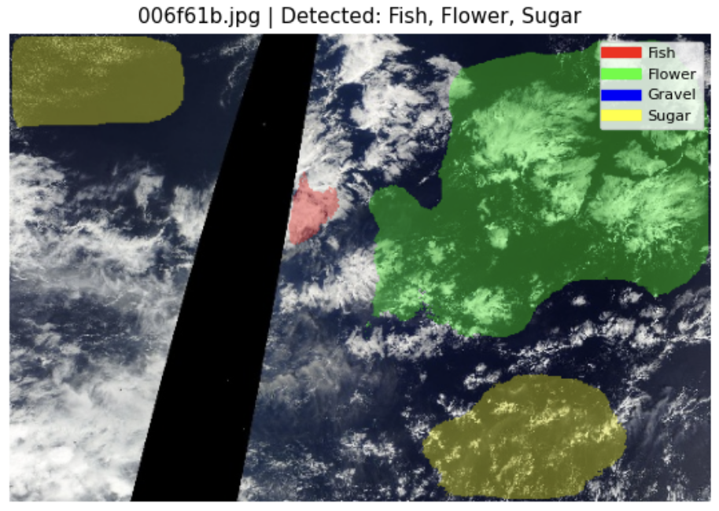
Figure 19: Model 2 Example Test Set Predictions

- Cloud Segmentation Models 3: Cloud Segmentation Using PSPNet
  - Executive Summary
This chapter documents the PSPNet model trained for the cloud-segmentation project: the method, the concrete configuration used, and the validation results. The model predicts four independent masks per image, one for each cloud organisation pattern (Fish, Flower, Gravel, Sugar). Because a pixel can belong to several patterns at once, the task is multi-label rather than multi-class.

Item | Value
Task | Semantic segmentation of cloud patterns in satellite images
Model | PSPNet with a ResNet-34 encoder pre-trained on ImageNet (segmentation_models_pytorch 0.5.0)
Input | 384 × 576 pixels, RGB
Output | Four independent masks: Fish, Flower, Gravel, Sugar (multi-label)
Data | 5,546 labelled images, split 4,991 train / 555 validation
Framework | PyTorch, Albumentations, OpenCV
Figure 20: Model 3 Project overview.

Training over 25 epochs is stable: training and validation loss decrease together and the validation Dice score rises from 0.5338 after the first epoch to 0.6039 at the end, without a widening train–validation gap. The final model reaches a macro Dice of 0.6039 and a macro IoU of 0.4357 on the 555 held-out validation images. That is close to the U-Net (ResNet-50) model trained on the identical validation split (macro Dice 0.6118), so the two architectures perform on par on this dataset.

  - Theoretical Background of the PSPNet Method
PSPNet (Pyramid Scene Parsing Network) is a segmentation architecture built around one central idea: a pixel is easier to classify when the model also knows the global context of the scene it sits in. A plain fully-convolutional network decides each pixel from a limited receptive field, which causes locally plausible but globally inconsistent labels. PSPNet adds a pyramid pooling module on top of the encoder feature map that pools the same features at several spatial scales at once and concatenates the results, so every pixel decision is informed by both local texture and the layout of the whole image.

The trade-off against U-Net is therefore: U-Net recovers spatial detail through skip connections, while PSPNet trades some of that detail for an explicit model of global context. For the diffuse, large-scale regions in this dataset the second property is the more relevant one, which is why PSPNet was selected as the counterpart architecture.
Component | Role in PSPNet | Role in this project
Encoder (backbone) | A CNN — here ResNet-34 — produces a downsampled feature map with rich semantic content. | Learns cloud texture, brightness and edge structure; ImageNet weights give a usable starting point despite the moderate dataset size.
Pyramid pooling module | Average-pools the encoder features onto 1×1, 2×2, 3×3 and 6×6 grids, reduces each level with a 1×1 convolution, upsamples all levels back and concatenates them with the un-pooled features. | Cloud patterns are large, diffuse and defined by their arrangement over the whole scene, which is exactly the global context this module adds.
Decoder head | A convolution over the concatenated pyramid features, followed by bilinear upsampling back to input resolution. | Produces the four full-resolution mask channels. The head is light — PSPNet has no U-Net-style skip connections, so fine boundaries are less sharp, which matters little for the soft cloud boundaries here.
Output layer | One channel per class with sigmoid activation in the multi-label case. | Four independent probability maps for Fish, Flower, Gravel and Sugar, thresholded at 0.5.
Figure 21: Model 3 Core PSPNet components and their role in this project.

  - Application of the PSPNet

Application of PSPNet in this Project
Architecture as instantiated. The model is created from segmentation_models_pytorch as PSPNet(encoder_name="resnet34", encoder_weights="imagenet", classes=4). Scheme 1 shows the resulting forward path with the tensor shapes it actually produces for a 384 × 576 input.
Figure 22 shows the PSPNet architecture as it was instantiated in this project: ResNet-34 encoder (stages 1–3), pyramid pooling module, segmentation head and bilinear upsampling.
One property of this configuration deserves to be stated explicitly, because it shapes the interpretation of every result below. The library default encoder_depth = 3 was not overridden, so only the first three stages of ResNet-34 are part of the forward path: the encoder output is a 48 × 72 feature map with 128 channels (stride 8), and the deeper stages 4 and 5 — which hold roughly 20 of the checkpoint’s 21.45 million parameters — are instantiated and stored but never evaluated. Effectively about 1.5 million parameters are trained and used. The model is therefore a PSPNet on a truncated ResNet-34 rather than on the full network. Training and inference use the same setting, so the reported scores are internally consistent; the point is that this was not a deliberate design choice but an unnoticed library default, and that the resulting model is small enough to be the most likely reason the learning curves flatten early.

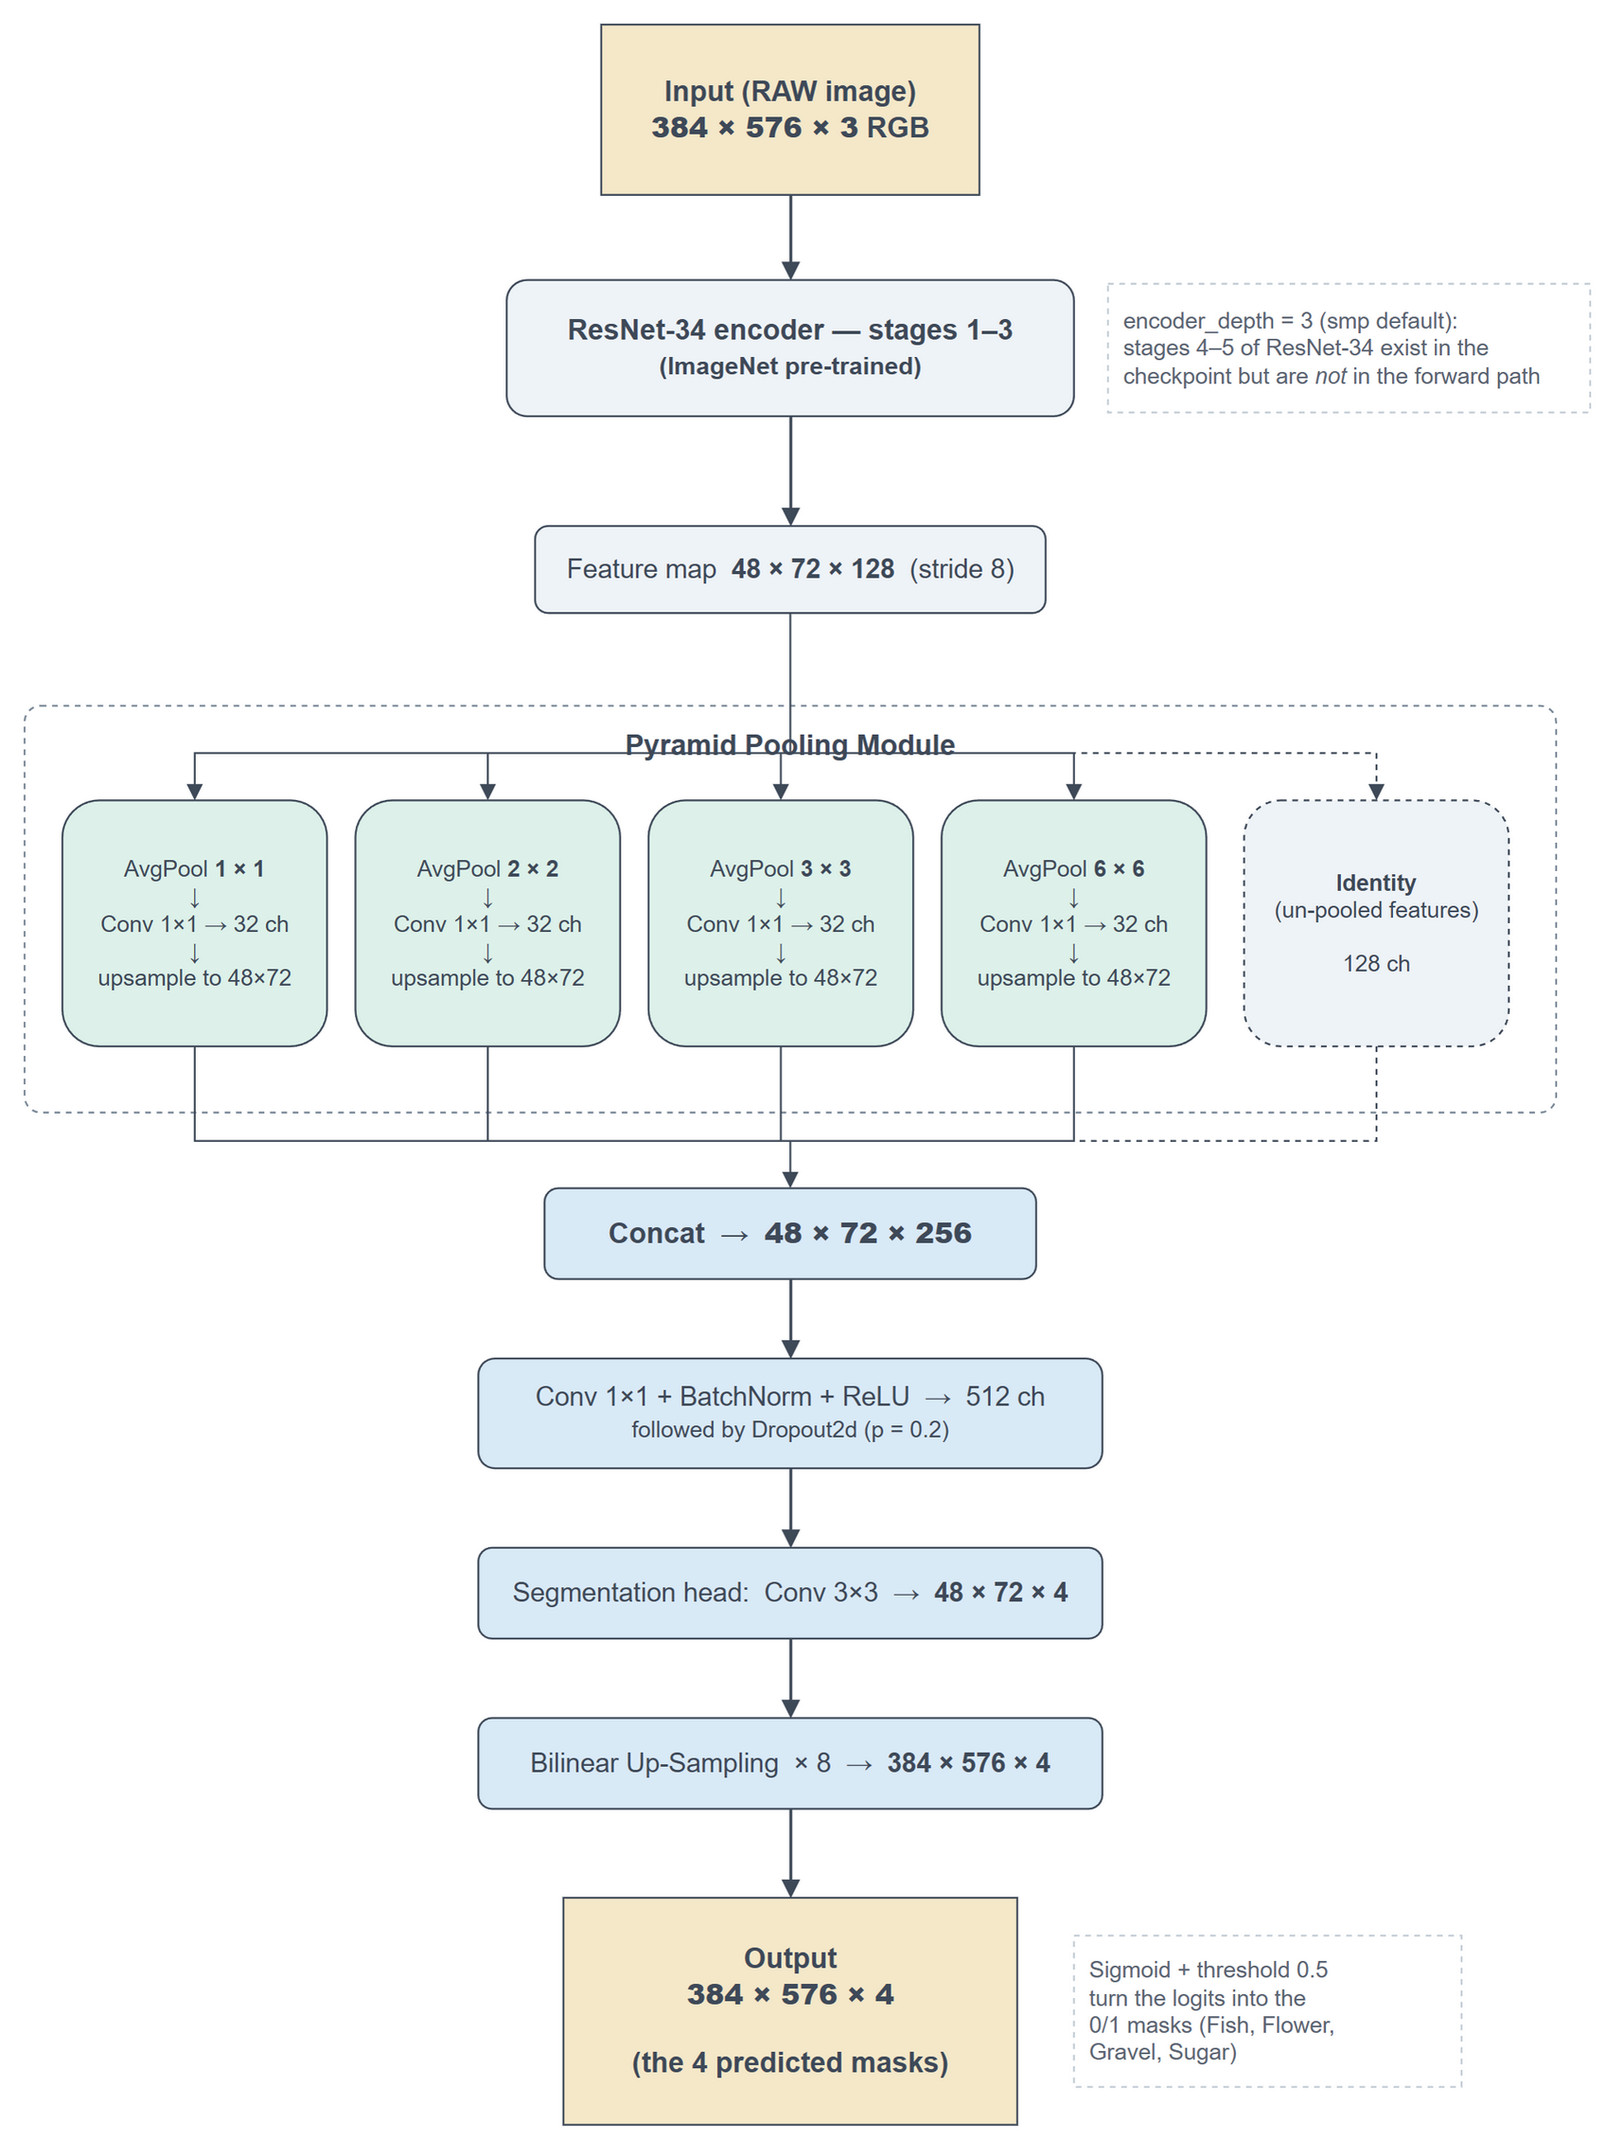
Figure 22: Model 3 instantiated ResNet-34 encoder PSPNet architecture

Training Setup. Images and masks are loaded at 384 × 576 by a custom dataset class that decodes the run-length-encoded masks from train.csv, applies the augmentation pipeline, and normalises the image with the ImageNet statistics the encoder expects.

Setting | Value
Loss | BCEWithLogitsLoss + multi-label Dice loss (weighted 1 : 1)
Optimizer | Adam, learning rate 1e-4, no scheduler
Epochs / batch size | 25 / 8
Augmentation (train only) | Horizontal flip (p = 0.3), vertical flip (p = 0.3), random brightness / contrast (p = 0.8), rotation (p = 0.6)
Train / validation split | Random 90 / 10 split on unique image names (random_state = 42), so all four label rows of an image stay on the same side
Parameters | 21.45 M stored in the checkpoint, of which ≈ 1.5 M lie in the forward path
Hardware | Single CUDA GPU
Figure 23: Model 3 training configuration

Two details are worth naming. First, the split is performed on unique image names, not on the label rows, which rules out leakage between training and validation. Second, validation data is never augmented, so the reported scores reflect the un-modified images. The split is a plain random split; a stratified split over the label combinations is planned as a separate optimisation step and is deliberately not part of this baseline.

Results and Interpretations
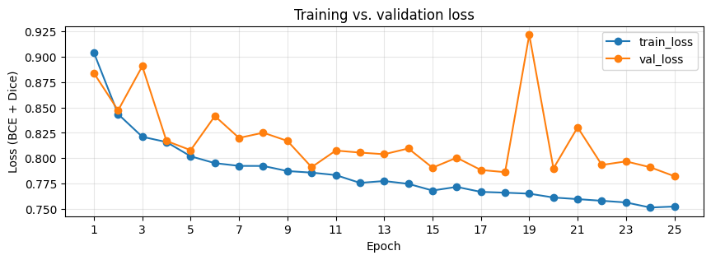
Figure 24: Model 3 training and validation loss (BCE + Dice) over 25 epochs

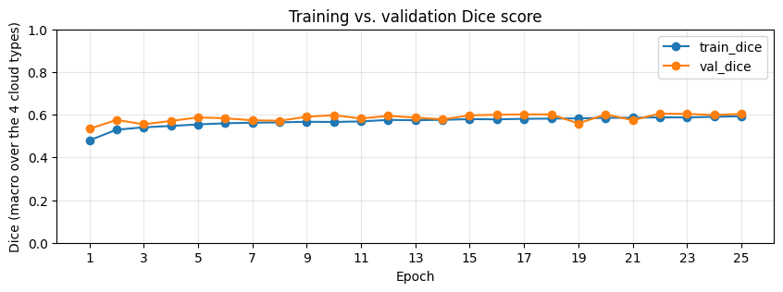
Figure 25: Model 3 training and validation Dice score over 25 epochs

Training loss falls smoothly from 0.9038 to 0.7524. Validation loss falls from 0.8838 to 0.7823, but does so far less evenly: from roughly epoch 4 onwards it sits consistently a little above the training curve and oscillates around a slowly falling trend, with one pronounced outlier at epoch 19 (0.9216, worse than the very first epoch). The training side of that epoch is entirely undisturbed — its loss step of −0.0010 is an ordinary value for this run, and training Dice even improves slightly — so whatever happened was invisible to the optimisation and affected only the evaluation.
The Dice curves are correspondingly flat. Training Dice rises from 0.4797 to 0.5927 and validation Dice from 0.5338 to 0.6039, with the best single epoch at 0.6053 (epoch 22). Almost all of that gain happens in the first ten epochs; from roughly epoch 10 onwards validation Dice moves within a band of about ±0.02 around 0.60 and the epoch-19 dip is the only visible excursion. The model has converged to what this configuration can reach, and more epochs alone would not help.
Validation Dice sits marginally above training Dice throughout. This is expected here rather than suspicious: the training scores are accumulated from the logits of the update steps, i.e. over a model that is still changing and over augmented images, while the validation scores describe a fixed model on untouched images.

Final validation metrics
The numbers below are produced by re-loading the saved checkpoint and scoring it on the validation loader, on the thresholded 0/1 masks the model actually outputs (threshold 0.5). Macro averages the four per-class scores, so a rare cloud type counts as much as a common one; micro pools the pixels of all four classes and is therefore dominated by the large ones.

Metric | Macro | Micro | Interpretation
Dice coefficient | 0.6039 | 0.6074 | Higher is better. Roughly 60 % overlap between predicted and true regions.
IoU | 0.4357 | 0.4362 | Higher is better. The stricter of the two overlap measures.
Loss (BCE + Dice) | 0.7823 | — | Lower is better. The quantity optimised, not a score.
Figure 26: Model 3 final validation metrics of the saved model

Macro and micro scores differ by less than 0.004, which means no single cloud type dominates the pixel count badly enough to distort the aggregate. The per-class table shows where the remaining differences sit.

Cloud type | Dice | IoU
Fish | 0.5125 | 0.3446
Flower | 0.6947 | 0.5322
Gravel | 0.5829 | 0.4114
Sugar | 0.6253 | 0.4548
Mean (macro) | 0.6039 | 0.4357
Figure 27: Model 3 Per-class validation scores
Flower is segmented best and Fish worst, a spread of 0.18 Dice between them considerably larger than any difference between the two architectures compared in section 5.

Predictions on unseen test images
The Kaggle test images carry no ground-truth masks, so they allow a qualitative check only. The trained model is run on the raw image and its output is thresholded into the same mask format the labelled data uses, which makes the existing overlay visualisation applicable to predictions. A cloud type counts as detected when its predicted mask covers at least 500 pixels.
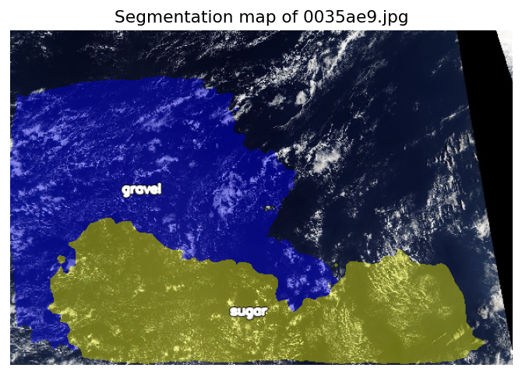
Figure 28: Model 3 segmentation map for test image 0035ae9.jpg
Verdict: the model detected: Gravel and Sugar.

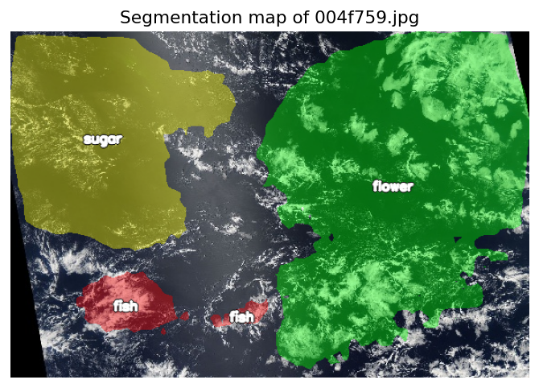
Figure 29: Model 3 segmentation map for test image 004f759.jpg
Verdict: the model detected: Fish, Flower and Sugar.
The predicted regions are large, contiguous and plausibly placed, which is consistent with the pyramid pooling module working as intended: the model commits to one pattern per area rather than scattering labels. Their boundaries are smooth and follow the cloud structure only approximately — the expected consequence of an architecture without skip connections whose output is upsampled by a factor of eight, and a visual explanation of why Dice stalls around 0.60. Figure 4 also shows the Fish weakness from Table 5: the Fish regions are small, fragmented patches, whereas Flower and Sugar are recovered as single coherent areas.

  - Conclusion
PSPNet is a suitable architecture for this task: the cloud patterns are large, diffuse regions whose identity depends on the arrangement of the whole scene, which is what the pyramid pooling module models explicitly. Training was stable over 25 epochs with no sign of overfitting, and the model reaches a macro Dice of 0.6039 and a macro IoU of 0.4357 on the held-out validation set — on par with the U-Net (ResNet-50) baseline evaluated on the identical split, and reached with roughly 1.5 million active parameters. This model should be regarded as a baseline, not as a tuned final model.
The following steps are the most promising ones from here, in this order:
- Give the encoder more depth than the library default of 3. The curves flatten after ten epochs and only about 1.5 million parameters are being trained, so capacity is the most plausible limit. Note that encoder_depth and upsampling are coupled: depth 4 requires upsampling 16 and depth 5 requires upsampling 32, otherwise the model silently returns masks smaller than the input. More depth also means a coarser feature map for the pyramid pooling module (24 × 36 or 12 × 18 instead of 48 × 72), so this should be run as an ablation over the three settings rather than assumed to be an improvement; depth 4 is the natural first attempt.
- Stratified train/validation split over the label combinations, so rare combinations are represented proportionally in both sets — planned as an explicit before/after comparison against this baseline.
- Per-class threshold optimisation on the validation set instead of the global 0.5 cutoff, which mainly targets the weak Fish class.
- Stabilise the batch-normalisation statistics — a larger batch size, or a lower batch-norm momentum — so that the validation score stops depending on which images happen to end an epoch. Section 4.1 traces the epoch-19 spike to this rather than to the optimiser, which makes it the more targeted fix; a learning-rate schedule is still worth adding, but for smoother convergence rather than to remove that outlier.

- Cloud Segmentation Models Comparison
  - Comparison with the PSP Model with the two U-Net Models
The PSPNet and the U-Net (ResNet-50) notebooks were deliberately aligned on their validation data: both build the image list from the same train.csv in the same order and split it with test_size = 0.1 and random_state = 42, so both are evaluated on the identical 555 images, with identically decoded ground truth. The scores below are therefore directly comparable. Everything else — encoder, augmentation pipeline and loss weighting — is part of the respective model recipe and was not aligned.

Cloud type | PSPNet (ResNet-34) | U-Net (ResNet-50) | Difference
Fish | 0.5125 | 0.5478 | − 0.0353
Flower | 0.6947 | 0.6962 | − 0.0015
Gravel | 0.5829 | 0.5729 | + 0.0100
Sugar | 0.6253 | 0.6301 | − 0.0048
Mean (macro) | 0.6039 | 0.6118 | − 0.0079
Figure 30: Macro Dice per cloud type, PSPNet vs. U-Net (ResNet-50) comparison

The overall difference of 0.0079 Dice is an order of magnitude smaller than the 0.18 spread between cloud types within either model, so neither architecture is meaningfully ahead on this dataset. The per-class column is more informative than the mean: on Flower, Gravel and Sugar the two models are within 0.01 of each other and the PSPNet is in fact a net +0.0009 ahead across those three. The entire mean gap comes from Fish, where the U-Net leads by 0.0353 — the same class the PSPNet handles worst in absolute terms (Table 5). As section 4.2 sets out, that weakness is not explained by the geometry of the Fish masks, so the difference should be read as an observation about these two runs rather than as evidence about skip connections.

Two caveats apply to reading this as an architecture comparison. The two models do not use the same encoder (ResNet-34 versus ResNet-50), and the PSPNet uses only the first three stages of its encoder, as described in section 3.1. The fair conclusion is therefore that a much smaller PSPNet — small by accident rather than by design — matches a considerably larger U-Net on three of four cloud types here, not that the architectures have been separated cleanly.

  - Comparison of Model Predictions
The three segmentation models were compared using the same seven test images. The table shows the cloud categories detected by each model for each image.

Image | U-Net + ResNet50 | U-Net + ResNet34 | PSPNet + ResNet34
002f507.jpg | Gravel, Sugar | Gravel, Sugar | Gravel, Sugar
0035ae9.jpg | Gravel, Sugar, Fish | Gravel, Sugar, Fish | Gravel, Sugar
0038327.jpg | Gravel, Sugar, Fish, Flower | Gravel, Sugar , Flower | Sugar, Fish, Flower
004f759.jpg | Gravel, Sugar, Fish, Flower | Sugar, Fish, Flower | Sugar, Fish, Flower
005ba08.jpg | Gravel, Sugar, Fish | Gravel , Fish | Gravel
006440a.jpg | Gravel, Sugar, Fish, Flower | Gravel, Sugar, Fish, Flower | Gravel, Sugar, Fish
006f61b.jpg | Sugar, Fish, Flower | Gravel, Sugar, Fish, Flower | Gravel, Sugar, Fish
Figure 31: Illustrative comparison of model prediction results

The results show that the models produced different predictions for several test images. U-Net with ResNet50 generally detected more cloud categories than the other two models. However, this comparison only shows the detected categories and does not indicate which prediction is more accurate because ground-truth masks are not available for the test images.

  - Final Model Comparison
Three segmentation models were compared using the overall Macro Dice score obtained on the validation set.
Model | Encoder | Best Validation Dice
U-Net | ResNet34 | 0.5974
U-Net | ResNet50 | 0.6118
PSPNet | ResNet34 | 0.6114
Figure 32: Final comparison of best validation dice results

U-Net with ResNet50 achieved the highest validation Dice score of 0.6118, followed very closely by PSPNet with ResNet34 with 0.6114. U-Net with ResNet34 achieved a score of 0.5974.

Based on the validation Dice score, U-Net with ResNet50 was selected as the best-performing model. However, the difference between U-Net with ResNet50 and PSPNet with ResNet34 is very small, indicating that their validation performance was very similar.

  - Recommended Model Selection
Three segmentation models were developed and evaluated in this project: U-Net with ResNet34, U-Net with ResNet50, and PSPNet with ResNet34.
Based on the validation results, U-Net with ResNet50 achieved the highest Macro Dice score of 0.6118. PSPNet with ResNet34 achieved a very similar score of 0.6114, while U-Net with ResNet34 achieved 0.5974.
Therefore, U-Net with ResNet50 was selected as the final model for generating predictions on the test images. The selected model was also used for the final test-set prediction and submission.

- Summary and Conclusion
This written report summarizes our Liora group project. It was created as part of the Liora data scientist course. The ambition was to learn and apply data preparation and machine learning techniques in a real-world context.

We cleansed the data and used existing data of labelled satellite images to train an algorithm that classifies cloud patterns correctly. We trained and applied two U-Net models and one PSPNet model.

While none of the three models was perfect, all of them yielded useful results. In the end, we chose the U-Net with ResNet50 as the final model for generating predictions on the test images. The selected model was also used for the final test-set prediction and submission.

More important than the selection of the final model for this exotic exercise were the skills that we learned as part of the program and the confidence to apply these skills in the real world over the course of our careers.

References
Buslaev, A., et al. (2020).
Albumentations: Fast and Flexible Image Augmentations. Information, 11(2), 125.
He, K., Zhang, X., Ren, S., & Sun, J. (2016).
Deep Residual Learning for Image Recognition. CVPR 2016; arXiv:1512.03385.
He, K., Zhang, X., Ren, S., & Sun, J. (2016).
Deep Residual Learning for Image Recognition. Proceedings of the IEEE Conference on Computer Vision and Pattern Recognition (CVPR).
Iakubovskii, P. (2019).
Segmentation Models PyTorch. GitHub. https://github.com/qubvel/segmentation_models.pytorch
Kaggle.
Competition dataset: Understanding Clouds from Satellite Images (Fish, Flower, Gravel and Sugar mask annotations).
Kaggle.
Understanding Clouds from Satellite Images. Kaggle Competition Dataset.
Kaggle
competition dataset: Understanding Clouds from Satellite Images / Understanding Cloud Organization (satellite images with Fish, Flower, Gravel, and Sugar mask annotations).
Loshchilov, I., & Hutter, F. (2019).
Decoupled Weight Decay Regularization. International Conference on Learning Representations (ICLR).
Paszke, A., et al. (2019).
PyTorch: An Imperative Style, High-Performance Deep Learning Library. Advances in Neural Information Processing Systems (NeurIPS).
Project tools
TensorFlow/Keras, OpenCV, NumPy, pandas, Albumentations, and Matplotlib.
Ronneberger, O., Fischer, P., & Brox, T. (2015).
U-Net: Convolutional Networks for Biomedical Image Segmentation. International Conference on Medical Image Computing and Computer-Assisted Intervention (MICCAI).
Ronneberger, O., Fischer, P., & Brox, T. (2015).
U-Net: Convolutional Networks for Biomedical Image Segmentation. MICCAI 2015; arXiv:1505.04597.
Zhao, H., Shi, J., Qi, X., Wang, X., & Jia, J. (2017).
Pyramid Scene Parsing Network. CVPR 2017; arXiv:1612.01105.

